
The Statutory Interpretation Infrastructure for SEND Governance
GuidelyEdu
Confidential Business Plan
March 2026

Table of Contents
1 Executive Overview 7
2 The Problem: Market, Regulatory and Operational Pressures 9
2.1 Growing Scale of SEND Need 9
2.2 Fragmented Evidence and Administrative Burden 9
2.3 Accountability, Compliance and Trust-Level Oversight 9
2.4 Buyer Concentration and Institutional Purchasing Logic 10
2.5 Resulting Market Opportunity 10
3 The Solution: Product & Technology Architecture 11
3.1 Platform Overview 11
3.2 Architectural Positioning 12
3.3 Core Architectural Layers 12
3.4 Ontology, Rule Library and Reasoning Model 13
3.5 Implementation Architecture and Development Stack 14
3.6 Integration, Security and Scalability 15
3.6.1 Integration-First Design 15
3.6.2 Data Governance and Institutional Security 15
3.6.3 Scalability and Deployment Design 16
3.7 Adoption and Operational Workflow 16
3.7.1 Adoption Principles 16
3.7.2 Practitioner Experience 16
3.7.3 End-to-End Operational Workflow 17
3.8 Current Product State and Planned Capability 18
3.8.1 Current Prototype Capability 18
3.8.2 Next-Stage Institutional Capability 18
3.9 Product and Deployment Roadmap 18
3.9.1 Current System State — Structured Prototype 19
3.9.2 Phase 1 — Validation and Core Engine Expansion (Months 0–6) 20
3.9.3 Phase 2 — Institutional Readiness and Trust Deployment (Months 6–18) 20
3.9.4 Phase 3 — Governance and Enterprise-Scale Expansion (Months 18–36) 20
3.9.5 Governance and Phase-Gate Controls 21
4 Research & Development, Innovation and Technical Defensibility 22
4.1 Core Innovation Position 22
4.2 Research and Development Activity 22
4.3 Product Innovation and Ongoing Development 23
4.4 Technical Defensibility and Intellectual Property Position 23
4.5 Strategic Significance of R&D to the Business 24
5 Market Opportunity & Validation 25
5.1 Market Opportunity 25
5.2 Validation Position 25
5.3 Early Validation Insights 26
5.4 Buyer Segmentation and Scale Logic 26
5.5 Stakeholder Analysis and Adoption Dynamics 27
5.6 Go-to-Market Strategy 27
5.7 Positioning, Partnerships and Pricing 28
5.8 Market Strategy Summary 28
6 Competitive Landscape & Structural Differentiation 29
6.1 Current Approaches in the Market 29
6.2 Strengths and Limits of Existing System Categories 29
6.3 Structural Gap in the Market 31
6.4 Comparative Summary 31
7 Commercial Model 33
7.1 Revenue Model 33
7.2 Pricing Structure 33
7.3 Indicative Pricing (Illustrative) 34
7.4 Revenue Scaling Logic 34
7.4.1 Five-Year Scale Potential 35
7.5 Sales Strategy 35
7.5.1 Institutional Adoption Funnel 35
7.6 Sales Channels 36
7.7 Trust Sales Cycle Dynamics 36
7.8 Unit Economics and Financial Logic 37
7.9 Commercial Risks and Mitigation 37
8 Financial Projections & Capital Efficiency 38
8.1 Founder Capital Commitment 38
8.2 Revenue & Institutional Scaling 38
8.2.1 Indicative Customer (Multi-Academy Trusts) Acquisition Cost (CAC) 39
8.3 Projected Profit & Loss: Profitability & Capital Efficiency 39
8.3.1 Operating Expenditure and Phase Investment 40
8.4 Projected Cash Flow & Liquidity 40
9 Business Operations, Compliance & Institutional Readiness 42
9.1 Operational Infrastructure 42
9.2 Governance, Compliance & Security Controls in Development 42
9.3 Intellectual Property, Institutional Readiness & Support 43
9.3.1 Controls to Be Completed Before First Trust Procurement 43
9.3.2 Institutional Readiness Position 43
10 Organisation, Staffing & Growth Plan 44
10.1 Operating Philosophy 44
10.2 Founder Role, Leadership Structure and Dependency 44
10.3 Organisational Structure 45
10.4 Contractor and Outsourcing Model 45
10.5 Phased Staffing Roadmap (Three-Year, Revenue-Aligned) 46
10.6 Organisational Scaling Model 47
10.7 Capability Priorities 47
11 Risk Management & Governance 48
11.1 Risk Context 48
11.2 Risk Management Approach 48
11.3 Risk Register 49
11.4 Governance Oversight 50
12 Founder Profile & Strategic Vision 51
13 Strategic Conclusion 52
14 Appendix 53
14.1 Appendix A: Product Design, Workflow and Governance Structure 53
A1. Platform Architecture and MIS Integration Overview 53
A2. GuidelyEdu Platform Overview and Core Functional Layers 54
A3. Platform Interface Wireframes (Separate Supporting Document) 55
A4. Product Workflow (Separate Supporting Document) 55
14.2 Appendix B: Validation Evidence & Commercial Support 55
B1. Practitioner Engagement Overview 55
B2. Supporting Extracts 56
B3. Key Findings from Early Engagement 57
B4. Strategic Implications for GuidelyEdu 57
B5. Evidence Position 57
B6. Near-Term Validation Priorities 58
14.3 Appendix C: Go-to-Market Visuals 58
C1. Phased Go-to-Market Roadmap 58
C2. Market Engagement & Expansion Channels 59
14.4 Appendix D: Financial Projections 60
D1. Revenue Assumptions (Pricing & Scaling) 60
D2. Revenue Progression (3-Year) 62
D3. R&D and Capitalised Product Development 63
D4. Cash Flow Forecast Summary (3-Year) 63
D5. Profit & Loss Summary (3-Year) 64
D6. Balance Sheet Summary (3-Year) 65
D7. Financial Model Methodology 65
14.5 Appendix E: Strategic and Stakeholder Analysis 66
E1. Stakeholder Analysis 66
E2. Adoption Barriers and Mitigation Strategy 67
E3. SWOT Analysis 68
E4. Comparative Technology and Platform Landscape 69
14.6 Appendix F: Intellectual Property Protection (Separate Supporting Document) 70
14.7 Appendix G: Data and Policy Sources 70
G1. Market Research Evidence Summary (Secondary Data) 70
G2. References 71

List of Tables
Table 6.4-i: Competitive Positioning Summary 31
Table 7.3-i: Illustrative School-Level Annual Subscription Examples 34
Table 7.3-ii: Illustrative Trust-Level Contract Examples 34
Table 7.5-i: Institutional Adoption Funnel 35
Table 8.2-i: Institutional Scaling Summary 38
Table 8.2-ii: Indicative Customer (MATs) Acquisition Cost (CAC) Summary 39
Table 8.3-i: Projected Profitability Financial Summary 39
Table 8.4-i: Cash Flow & Liquidity Summary 41
Table 10.5-i: Three-Year Phased Staffing Roadmap (Revenue-Aligned) 46
Table 10.6-i: Phased Scaling Structure (Revenue-Aligned) 47
Table 11.3-i: Risk Register 49
Table 14.2-i: Appendix B1 - Summary of practitioner and Sector Engagement 55
Table 14.4-i: Appendix D1 - Pricing Tier 60
Table 14.4-ii: Appendix D1 - Core Pricing Assumptions 60
Table 14.4-iii: Appendix D1 - Contract Values 61
Table 14.4-iv: Appendix D1 - Institutional Scaling Summary 61
Table 14.4-v: Appendix D2 - Revenue Progression (3-Year) 62
Table 14.4-vi: Appendix D3 - R&D and Capitalised Product Development 63
Table 14.4-vii: Appendix D4 – Cash Flow Forecast Summary (3-Year) 63
Table 14.4-viii: Appendix D5 - Profit & Loss Summary (3-Year) 64
Table 14.4-ix: Appendix D6 - Balance Sheet Summary (3-Year) 65
Table 14.5-i: Appendix E1 - Decision-Makers (Trust Level) 66
Table 14.5-ii: Appendix E1 - Operational Users (School Level) 66
Table 14.5-iii: Appendix E2 - Adoption Barriers and Mitigation Measures 67
Table 14.5-iv: Appendix E3 - SWOT Analysis 68
Table 14.5-v: Appendix E4 – Comparative Technology and Platform Landscape 69
Table 14.7-i: Appendix G1 – Market Research Evidence Summary (Secondary Data) 70

List of Figures
Figure 3.1-i: Illustrative Platform Overview 10
Figure 3.2-i: Interpretation Layer within Existing School Systems 11
Figure 3.3-i: Core Architectural Layer Model 11
Figure 3.7-i: Operational Workflow Swimlane 16
Figure 3.9-i: Product and Deployment Roadmap 18
Figure 8.4-i: Revenue, EBITDA and Closing Cash Balance (Years 1–3) 40
Figure 10.3-i: Organisational Structure (Revenue-aligned Model) 44
Figure 11.2-i: Staged Risk Reduction Model 48
Figure 14.1-i: Appendix A1 - Platform Architecture and MIS Integration Overview 53
Figure 14.1-ii: Appendix A2 - Platform Overview and Core Functional Layers 54
Figure 14.2-i: Appendix B2 – Supporting Evidence of Practitioners Engagement 56
Figure 14.3-i: Appendix C1 - Go-to-Market Roadmap 58
Figure 14.3-ii: Appendix C2 - Market Engagement & Expansion Channels 59
Figure 14.4-i: Appendix D2 - Revenue Growth Projection (3-year) 62

Executive Overview
The United Kingdom’s Special Educational Needs and Disabilities (SEND) system is under increasing operational and statutory pressure. Rising levels of need, stronger accountability expectations, and expanding evidential requirements have made SEND documentation, review preparation, and compliance activity more complex across schools and Multi-Academy Trusts (MATs). In many settings, the evidence schools rely on to demonstrate support, provision, and decision-making remains fragmented across narrative notes, spreadsheets, templates, emails, and disconnected systems. This includes observations, intervention records, review notes, communications, and decision trails. That fragmentation increases administrative burden for Special Educational Needs Coordinators (SENCOs), senior leaders, and trust teams, while weakening consistency, visibility, and audit-readiness.
GuidelyEdu addresses this challenge as a governance-aligned platform designed to transform fragmented SEND evidence into structured, explainable, and statutory review-ready documentation. Developed for the UK education market, the platform is designed to work alongside existing school processes and Management Information Systems (MIS) rather than replace them. GuidelyEdu helps schools and trusts strengthen accountability, improve oversight, identify documentation gaps earlier, and prepare more effectively for inspections, Education, Health and Care Plan (EHCP) reviews, and wider governance activity by converting dispersed records into clearer, traceable, and audit-ready documentation, while preserving professional judgement as a human-led responsibility.
The platform’s core innovation lies in embedding deterministic statutory reasoning within SEND documentation workflows, enabling fragmented evidence to be converted into structured, explainable, and governance-ready outputs rather than remaining as isolated records across multiple systems. It applies rule-based logic to assess recorded information against the expectations of the SEND Code of Practice and translate that information into more consistent, review-ready documentation. In practice, this helps schools and trusts identify missing or weak documentation earlier, reduce last-minute manual reconstruction, and improve confidence that records are clearer, more defensible, and better prepared for statutory review.
GuidelyEdu’s differentiation lies in moving beyond passive record-keeping towards structured statutory interpretation within everyday school workflows. Its unique selling proposition is its ability to convert fragmented SEND evidence into structured, explainable, and governance-ready documentation through deterministic statutory reasoning embedded within existing school workflows. This differentiation does not rest solely on interface design, but on the structured codification of SEND statutory logic, workflow sequencing, documentation requirements, and governance interpretation within a platform intended to be transparent, explainable, and practically usable in school settings.
The commercial rationale is strengthened by the fact that SEND compliance is a mandatory feature of the UK education system. Schools are required to document and demonstrate graduated response, intervention, and inclusive practice, creating an ongoing need for clear, consistent, and defensible documentation. Early practitioner engagement indicates that fragmentation, inconsistency, and manual review preparation are recognised operational problems in practice, providing credible early support for the proposition and a sound basis for pilot implementation and commercial testing. The business does not rely on assumed market demand alone. Its next validation stage is structured pilot conversion designed to test workflow fit, workload reduction, documentation quality, and institutional usability in live school settings before wider commercial rollout.
The route to scale is institutional adoption rather than fragmented school-by-school sales. While school-level use is central to implementation, the Multi-Academy Trust represents the most credible primary buyer, as budget authority, governance oversight, cross-school accountability, and the need for greater consistency across academies are increasingly concentrated at trust level. This supports a phased route to market: live school validation, initial trust-level adoption, and broader portfolio rollout over time. Scalability is driven not by high-volume low-value customer acquisition, but by institution-level contracting, portfolio rollout within MATs, recurring subscription revenue, and expansion through existing customer relationships over time. As the platform matures, trust-level dashboards and reporting functionality are intended to strengthen portfolio oversight and increase the value of wider trust deployment.
The financial model reflects a phased approach to institutional adoption, combining prudent cost control with measured commercial scaling. Year 1 is treated as a non-revenue validation phase, focused on product refinement, pilot implementation, and early market testing rather than immediate income generation. Revenue is projected to increase from £0 in Year 1 to £168,800 in Year 2 and £378,390 in Year 3, driven by paid individual school subscriptions, initial trust-level commercial agreements, and broader rollout across academy portfolios. This growth profile reflects a deliberate route to market in which validation in live settings supports wider institutional adoption over time. EBITDA is projected to turn positive in Year 2 at £7,146 and increase to £90,188 in Year 3, representing a 24% EBITDA margin. The business remains supported by founder loan funding throughout the forecast period, reducing dependence on external capital during the initial validation and early commercialisation stages.
Overall, GuidelyEdu presents a credible, lean, and scalable route to commercialise governance-aligned SEND documentation and compliance infrastructure for the UK education sector.


The Problem: Market, Regulatory and Operational Pressures
The operational and statutory pressures identified in the Executive Overview are reinforced by broader developments across the United Kingdom SEND system. Rising levels of need, stronger accountability expectations, and growing evidential requirements are increasing the importance and complexity of SEND documentation, review preparation, and compliance activity across schools and Multi-Academy Trusts.
This section examines the wider conditions that are intensifying those pressures and increasing their commercial and institutional significance, including the growing scale of need, rising operational burden, stronger regulatory and accountability expectations, and the concentration of oversight at trust level.

Growing Scale of SEND Need
The Special Educational Needs and Disabilities (SEND) system in the United Kingdom is operating at a scale that is increasing demand for more structured documentation and compliance support across schools and Multi-Academy Trusts (MATs). More than 1.7 million pupils are identified as having special educational needs, representing almost one in five school pupils, while around 482,600 pupils in schools have an Education, Health and Care Plan (EHCP). As volumes continue to rise, so does the amount of statutory evidence, review activity, and administrative coordination required to support compliant SEND practice.

Fragmented Evidence and Administrative Burden
Across schools and MATs, records relating to pupils’ needs, support, progress, and review history are often spread across multiple systems. These records, observations, assessments, interventions, communications, and review documents form the evidence schools rely on to understand pupils’ needs, demonstrate the support provided, and show progress over time. School administration systems, local trackers, pastoral records, emails, and professional notes were not designed to function as a single statutory workflow. These systems can store information, but they do not reliably structure, interpret, or govern that evidence for statutory purposes. As a result, schools remain dependent on manual collation and local workarounds to prepare documentation for reviews, funding decisions, and accountability processes.
This creates growing pressure on Special Educational Needs Coordinators and inclusion staff, whose time is increasingly absorbed by evidence gathering, coordination, document preparation, and follow-up on incomplete records. As demand rises, this reduces capacity for direct pupil support, early intervention, and strategic oversight. The market need is therefore not simply for better storage, but for infrastructure that can reduce administrative burden and support more consistent documentation.

Accountability, Compliance and Trust-Level Oversight
Regulatory expectations are increasing the need for more consistent and defensible SEND documentation. Schools are now expected not only to deliver appropriate support, but to demonstrate through clear, traceable, and review-ready records that needs have been assessed, support has been planned and delivered, and progress has been monitored in line with statutory guidance. As scrutiny from Local Authorities and wider accountability processes increases, the quality of documentation becomes more closely linked to funding decisions, statutory reviews, and exposure to formal challenge.
At the same time, Multi-Academy Trusts are expected to exercise oversight across multiple academies, even though documentation standards and systems often vary from one school to another. This creates a governance problem as well as a compliance one. Without consistent and comparable records, trust leaders have limited visibility into whether statutory expectations are being met, where risks are emerging, and how practice differs across the portfolio.
These combined pressures strengthen the market need for infrastructure that can standardise SEND documentation, improve traceability, and support trust-level assurance at scale.

Buyer Concentration and Institutional Purchasing Logic
This market opportunity is commercially significant because the most credible buyer is not the individual school acting alone, but the Multi-Academy Trust responsible for oversight across multiple academies. MATs represent the more practical entry segment because budget authority, governance accountability, and cross-school quality assurance are increasingly concentrated at trust level. The most relevant initial buyer universe is therefore small-to-mid-sized trusts, where a single purchasing decision can improve documentation consistency, review readiness, and evidential visibility across several schools.
In this context, SEND documentation is not discretionary administration but part of core operational and statutory practice. Spending that reduces documentation risk, strengthens defensible oversight, and improves trust-wide assurance is therefore more likely to secure budget priority than optional workflow tools. Commercially, this creates a more efficient route to market than fragmented school-by-school sales, because one institutional agreement can support wider rollout and deliver clearer administrative and governance value across the trust portfolio.

Resulting Market Opportunity
The combination of rising SEND volumes, increasing operational burden, stronger regulatory scrutiny, and trust-level governance requirements creates a clear market opportunity for compliance-focused infrastructure within the United Kingdom SEND system. The sector increasingly requires systems that can support the structured capture, interpretation, and governance of SEND evidence at scale. For GuidelyEdu, this supports a trust-led commercial strategy in which early school-level validation underpins entry into MAT procurement discussions, followed by broader portfolio rollout once institutional value has been demonstrated.
Selected market and policy evidence supporting the scale and relevance of this opportunity is summarised in Appendix G1.


The Solution: Product & Technology Architecture

Platform Overview
GuidelyEdu is a cloud-based, multi-tenant Software as a Service (SaaS) platform created to improve the consistency, visibility, and evidential quality of Special Educational Needs and Disabilities (SEND) documentation across schools and Multi-Academy Trusts (MATs). It addresses the operational, regulatory, and evidential pressures set out in Section 2 by converting dispersed SEND records into structured, explainable, and review-ready documentation outputs.
Rather than replacing existing school systems, GuidelyEdu sits alongside them as a compliance-oriented interpretation and documentation layer. Its role is to help schools and trusts move from fragmented narrative records and manual collation towards clearer evidence structures, more consistent documentation standards, and more traceable outputs for annual reviews, EHCP processes, inspections, and wider governance activity.
At the centre of the platform is the Statutory Reasoning Engine (SRE), supported by a machine-readable SEND statutory ontology and structured evidence workflows. These components assess recorded evidence against defined statutory conditions as documentation is created or imported, making evidential gaps easier to identify, strengthening coherence across records, and supporting outputs that are more defensible, auditable, and operationally useful.
GuidelyEdu has been built as a structured prototype. Its core architecture is in place, including the ontology model, reasoning structure, evidence workflows, and foundational output logic. The platform has not yet been deployed to end users, but the prototype provides a concrete operational basis for pilot validation and staged commercial rollout.
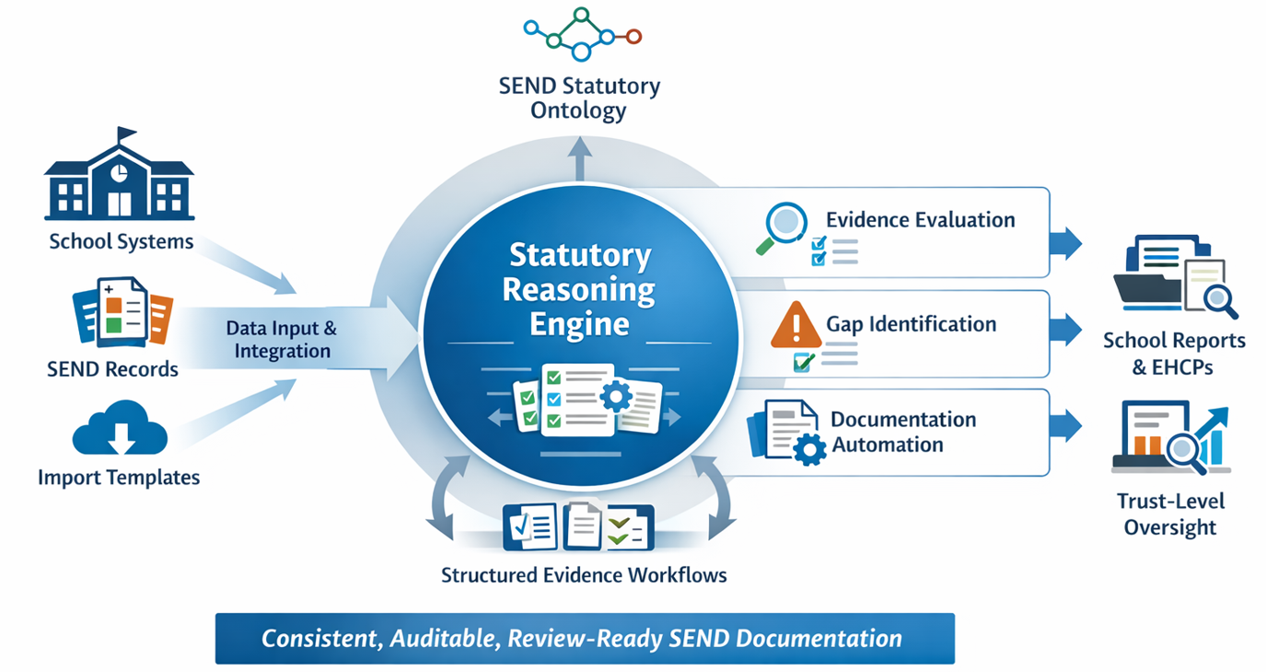
Figure 3.1-i: Illustrative Platform Overview
Supporting product architecture, workflow, and platform visuals are provided in Appendix A.

Architectural Positioning
In practical terms, GuidelyEdu sits between raw SEND activity and final review-ready outputs. Existing school systems continue to hold core administrative and pupil data, while GuidelyEdu provides the interpretation, reasoning, and documentation logic that those systems do not typically deliver natively.
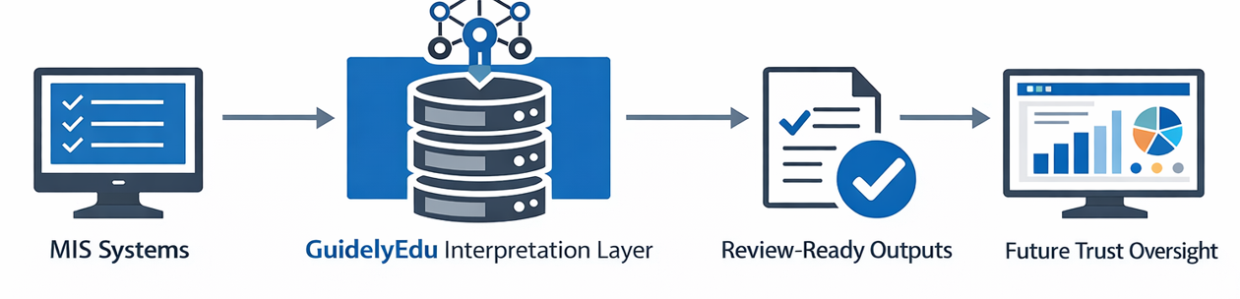
Figure 3.2-i: Interpretation Layer within Existing School Systems
GuidelyEdu operates as an application-layer platform rather than as a feature embedded within third-party school software. It works alongside widely used school Management Information Systems such as SIMS, Arbor, and Bromcom rather than replacing them. Its role is to introduce a compliance-oriented interpretation layer within existing documentation workflows, allowing SEND evidence to be assessed not only for completeness, but also for statutory relevance, coherence, and evidential sufficiency.
This positioning reduces institutional disruption and supports adoption within schools and trusts already dependent on established administrative platforms. It also strengthens procurement practicality by allowing GuidelyEdu to complement existing infrastructure while adding a differentiated compliance capability.
The platform supports practice by structuring observations, interventions, review activity, and related evidence in a form suitable for statutory interpretation; evaluating whether recorded information meets defined conditions within the graduated response and wider review process; identifying missing or weak documentation earlier; and converting accumulated records into clearer, more traceable outputs for operational use, review preparation, inspection, governance, and accountability. In this way, GuidelyEdu does not replace school Management Information Systems, but strengthens the evidential and documentation layer around them.
GuidelyEdu’s primary operational users are teachers, SENCOs, support staff, and school leaders who contribute to or rely on SEND documentation, with broader trust-level oversight capability forming part of later-stage institutional expansion.

Core Architectural Layers
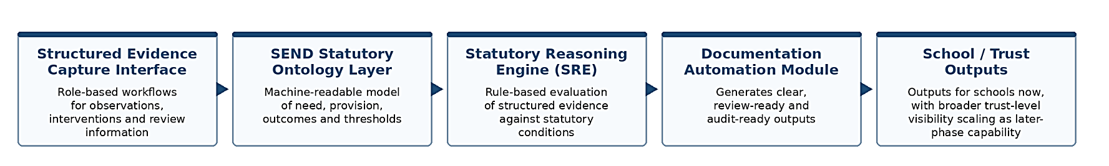
Figure 3.3-i: Core Architectural Layer Model
GuidelyEdu is structured as a set of interdependent architectural layers, each supporting a distinct stage in the documentation and interpretation process.
- Structured Evidence Capture Interface: Role-based workflows aligned to the graduated response process enable teachers, SENCOs, and support staff to record observations, interventions, and review information in formats designed for downstream statutory interpretation.
- SEND Statutory Ontology Layer: A proprietary, machine-readable ontology models the relationships between pupil need, provision, outcomes, and evidential thresholds, translating SEND guidance into structured regulatory logic.
- Statutory Reasoning Engine (SRE): The SRE applies deterministic rule-based reasoning to structured evidence, evaluating whether accumulated records satisfy relevant statutory conditions. Unlike probabilistic AI systems, its outputs remain transparent, consistent, auditable, and fully traceable.
- Documentation Automation Module: Evaluated evidence is transformed into structured outputs, including annual review documentation, EHCP evidence packs, review summaries, and other records that support statutory and operational processes.
- School / Trust Output Layer: The platform produces outputs for immediate school-level use and, as later-phase institutional capability matures, broader trust-level visibility through reporting, indicators, and governance-oriented oversight tools.
These five layers form an integrated documentation and interpretation architecture in which compliance support is embedded within SEND workflows rather than treated as a retrospective administrative exercise.

Ontology, Rule Library and Reasoning Model
At the centre of GuidelyEdu’s documentation framework is the interaction between the SEND statutory ontology and the Statutory Reasoning Engine (SRE). These components enable SEND evidence to be structured, evaluated against defined statutory conditions, and translated into more consistent and explainable documentation outputs.
Proprietary SEND Statutory Ontology. The ontology serves as the platform’s source-of-truth knowledge model. It defines the principal concepts and relationships used across the system, including pupil need, provision, outcomes, evidence types, review events, and threshold conditions. In practical terms, it formalises how different elements of SEND evidence relate both to one another and to statutory expectations.
The ontology is organised across five knowledge domains:
- Need Taxonomy — categorisation of primary and secondary areas of need
- Provision Taxonomy — classification of interventions and support mapped to identified needs
- Outcome Framework — progress indicators aligned with EHCP objectives and review cycles
- Threshold Definitions — encoded conditions translating statutory language into operational evaluation rules
- Relationship Mappings — formal links between need, provision, outcomes, evidence, and review events
Rule Library and Execution Model. The rule library sits within the Statutory Reasoning Engine as a backend application service inside the GuidelyEdu platform. Third-party MIS remain connected data sources where required, while GuidelyEdu provides the interpretation and documentation logic.
Structured evidence captured through GuidelyEdu workflows, imported records, and connected MIS data is mapped into the ontology-defined model and evaluated against relevant statutory conditions. The resulting determinations then pass to the documentation automation layer, audit trail, reporting features, and later-stage governance dashboards.
Statutory Reasoning Engine (SRE). The SRE evaluates evidence across four principal dimensions:
- Sequential compliance — whether the graduated response has been followed in the appropriate order
- Evidential sufficiency — whether the available documentation meets defined thresholds
- Proportionality — whether support appears aligned to identified need
- Outcome progression — whether recorded evidence demonstrates movement towards specified outcomes
Each rule comprises a defined condition, an explicit logical evaluation, and a resulting determination. As new evidence is captured, the engine reassesses the relevant conditions and updates documentation status accordingly.
Explainability and Auditability. For each evaluation, the platform shows the rule applied, the evidence considered, whether the relevant conditions were met, and the reasoning pathway that led to the determination. This makes outputs traceable and suitable for regulated education environments in which documentation must be understood and defended rather than treated as a black box.
Integrated Effect. The SEND statutory ontology provides the structural model, while the SRE applies evaluative logic against defined conditions. The ontology maps evidence into statutory categories, relationships, and thresholds, while the SRE evaluates that evidence against defined conditions. This enables the platform to apply statutory logic consistently, explain outcomes transparently, and generate traceable documentation outputs. In practical terms, this moves SEND documentation beyond passive record storage towards structured statutory interpretation.
The practical implementation of the ontology, rule library, and backend service architecture is outlined in Section 3.5.

Implementation Architecture and Development Stack
The platform uses a practical software stack suited to an early-stage regulated SaaS product. The SEND ontology serves as the source-of-truth knowledge model for the domain and has been developed in Protégé. This is where the core SEND concepts and relationships are formally defined, including links between pupil need, provision, outcomes, evidence types, review events, and threshold conditions.
Those relationships are encoded within the operational platform through structured backend data models and database relationships. The primary data layer uses PostgreSQL, supporting both stable relational structures and flexible evidence payloads where semi-structured records are required. Core entities including pupils, needs, provisions, outcomes, evidence records, and review cycles are represented in structured tables, while selected documentation payloads are stored in flexible formats where appropriate.
The backend application layer is structured as a cloud-based service, with the Statutory Reasoning Engine (SRE) operating as an internal backend service within GuidelyEdu. The rule library sits directly inside the SRE, with rule definitions stored in database-backed rule tables within PostgreSQL. Ontology and rule changes are version-controlled to preserve traceability, consistency, and auditability as the platform matures.
At runtime, evidence captured through GuidelyEdu workflows, imported through structured templates, or received through connected school systems enters the backend application layer and is mapped against the ontology-defined model. The SRE then applies rule-based evaluation against defined statutory conditions, and the resulting determinations pass to the documentation engine, audit trail, reporting outputs, and later-stage governance dashboards.
This implementation architecture preserves the ontology as the conceptual source of truth while using structured backend services, data models, and rule execution logic suited to deployment in a regulated education environment.

Integration, Security and Scalability
GuidelyEdu is structured to integrate with existing school systems, protect sensitive SEND data, and support phased deployment from individual schools to wider trust environments. This section therefore focuses on interoperability, institutional governance, and scalable deployment architecture.

Integration-First Design
GuidelyEdu follows an integration-first model in which schools and trusts retain their existing operational systems while the platform connects to relevant data sources and supports SEND documentation processes without requiring system replacement.
This model is based on three principles. First, interoperability takes priority over replacement, allowing established systems to remain in place. Second, duplicate data entry is minimised wherever possible in order to reduce administrative burden. Third, deployment can begin incrementally at school, cohort, or academy level before wider rollout.
Integration is supported through secure API connectivity, compatibility with established education data connectors including Wonde and Groupcall, and controlled synchronisation settings that allow institutions to manage what data is shared. This reduces migration risk, preserves institutional data control, and lowers adoption barriers.

Data Governance and Institutional Security
SEND data is highly sensitive and subject to strict safeguarding and data protection obligations. GuidelyEdu is therefore structured around a security-by-design approach aligned with UK GDPR and the Data Protection Act 2018.
Access is governed through a hierarchical role-based permissions model aligned with school and trust structures, ensuring that users can access only the information relevant to their responsibilities. Significant system actions, including authentication events, record access, data modification, and report generation, are logged to support safeguarding review, auditability, and compliance assurance.
Data is encrypted at rest and in transit using industry-standard protocols, while customer environments are logically separated within a secure multi-tenant architecture. This supports lawful processing, evidential integrity, and institutional confidence in the handling of sensitive SEND records.

Scalability and Deployment Design
GuidelyEdu is architected to scale from individual school deployment to trust-wide rollout without requiring structural redesign. Its cloud-native multi-tenant architecture supports resilience, low marginal onboarding cost, and centralised platform updates as adoption increases.
The platform uses a modular structure in which functionality is activated through configuration rather than custom development. This supports phased deployment across academies, faster time-to-value, and scalable delivery without equivalent growth in operational overhead. It also supports differentiated pricing and commercially efficient expansion across trust portfolios.

Adoption and Operational Workflow
GuidelyEdu is structured for adoption within high-pressure school environments where new systems are often resisted if they increase workload, require duplicate entry, or disrupt established routines. The platform therefore prioritises low-friction implementation, role-appropriate workflows, and immediate operational value.

Adoption Principles
The adoption model is based on four principles:
- No parallel logging — wherever possible, data flows from existing systems into GuidelyEdu, reducing duplicate entry.
- Workflow continuity — schools retain familiar tools and routines, with GuidelyEdu operating as an interpretive layer rather than a replacement system.
- Incremental deployment — implementation can begin with a single cohort, school, or academy before wider rollout.
- Immediate value — the platform generates documentation insight from the first review cycle while remaining adaptable to future regulatory updates.
These principles reduce implementation resistance and align adoption with the operational realities of schools and Multi-Academy Trusts.

Practitioner Experience
For school practitioners operating under sustained workload pressure, adoption must require minimal setup and no technical configuration. GuidelyEdu is therefore structured so that integration complexity is handled centrally rather than by frontline staff.
Once connectivity is authorised through established data connectors or secure API integration, relevant pupil and documentation data can synchronise automatically. Users access the platform with core information already populated, without manual mapping or technical setup. Where integration approval is delayed, structured import templates support immediate onboarding until full synchronisation is completed.
This approach supports immediate usability, low implementation friction, and no requirement for practitioners to act as system administrators.

End-to-End Operational Workflow
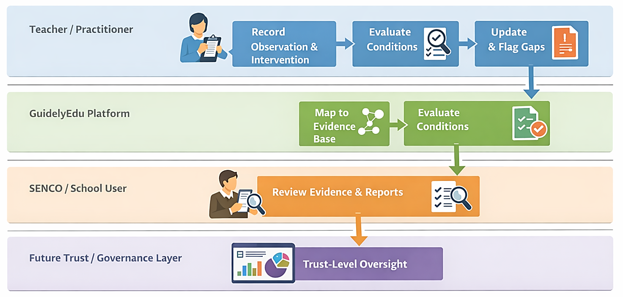
Figure 3.7-i: Operational Workflow Swimlane

The workflow operates as follows:
- A teacher records a brief structured observation, the intervention used, and the pupil response.
- The platform maps that information through the SEND statutory ontology and adds it to the pupil’s evolving evidence base.
- The Statutory Reasoning Engine evaluates the accumulated evidence against relevant conditions and review thresholds.
- The platform updates documentation status, highlights evidential gaps, and prepares review-ready outputs where appropriate.
- A SENCO or school leader reviews the evidence position and resulting documentation.
- At later institutional stages, broader trust-level visibility can be provided where enabled.
In this model, the practitioner’s workflow remains largely unchanged. The user records information once, while the platform performs the downstream classification, evaluation, and documentation support. This reduces retrospective collation and allows staff to focus more on provision and less on paperwork.

Current Product State and Planned Capability

Current Prototype Capability
GuidelyEdu currently exists as a structured prototype with the core architecture already established for early validation and controlled implementation. At this stage, the platform provides a working basis for testing whether SEND evidence can be captured, structured, and interpreted in a more consistent and explainable way within routine school practice.
The prototype has not yet been deployed to end users, integrations remain configurable case by case, rule coverage represents a subset of the wider regulatory framework, and implementation still requires direct oversight. This is consistent with the current objective of validating the core reasoning model, refining ontology logic, and preparing the platform for pilot use.

Next-Stage Institutional Capability
Beyond the current prototype, GuidelyEdu has a clear pathway towards broader institutional capability. Planned next-stage development includes wider rule coverage, deeper ontology refinement, more standardised MIS connectivity, automated review-cycle support, and broader governance-oriented reporting and oversight functionality. These capabilities form part of the platform’s staged progression rather than its current live position and remain dependent on successful pilot validation, technical refinement, and phased deployment.

Product and Deployment Roadmap
GuidelyEdu follows a staged roadmap from structured prototype validation to trust-scale deployment. Figure 3.9-i summarises the main phases, delivery priorities, and success indicators across that progression.
Development is sequenced around validated performance, institutional demand, and deployment readiness, covering ontology and rule coverage, backend services, database modelling, integration connectors, reporting capability, administration tooling, and deployment controls.
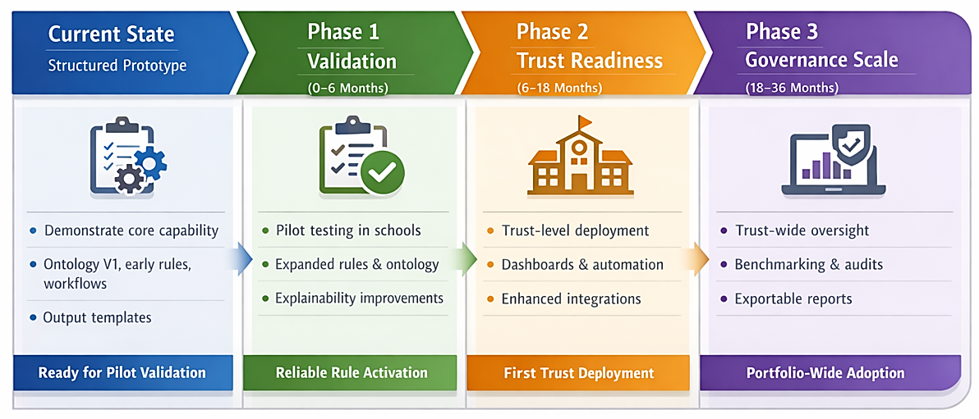
Figure 3.9-i: Product and Deployment Roadmap

Current System State — Structured Prototype
The platform is currently at a structured prototype stage, with modular architecture defined and core components implemented to support demonstration, validation, and pilot preparation.
Trust-level governance dashboards are reserved for the next stage of development.
Implemented capabilities include:
- Authentication and user management, including role-based access control and readiness for Single Sign-On integration
- Version 1 of the SEND statutory ontology, aligned to graduated response evidence domains
- Structured evidence workflows for observations, interventions, review cycles, and pupil response recording
- Initial rule sets for common documentation and threshold scenarios
- Foundational documentation output templates for review summaries and evidential support
Current prototype constraints include:
- No live end-user deployment at the current stage
- MIS integrations configured selectively rather than through fully standardised connectors
- Rule coverage representing a subset of the wider regulatory framework, with further expansion required
- Trust-level governance dashboards reserved for the next stage of development.
These constraints are appropriate to the current validation stage and do not limit the immediate objective of demonstrating embedded reasoning, refining ontology logic, and preparing the platform for pilot use.

Phase 1 — Validation and Core Engine Expansion (Months 0–6)
Focus: validate the prototype in live pilot conditions and strengthen the reliability of the core reasoning framework.
Key deliverables:
- Expanded rule library aligned with escalation and review thresholds
- Ontology refinement informed by pilot feedback
- Enhanced explainability interface for rule transparency
- Structured pilot deployment toolkit
- Initial academy-level reporting prototype
Success indicators:
- Reliable and consistent rule activation
- Positive practitioner validation feedback
- Alignment between generated outputs and statutory expectations

Phase 2 — Institutional Readiness and Trust Deployment (Months 6–18)
Focus: enable scalable Multi-Academy Trust deployment and broader governance readiness.
Capability expansion:
- Fuller ontology coverage, including more complex documentation scenarios
- Governance dashboard architecture for multi-academy oversight
- Portfolio-level compliance and escalation indicators
- Automated review-cycle management
- Role-based access controls aligned with trust structures
Infrastructure maturation:
- Production-grade multi-tenant deployment
- Secure data partitioning across academies
- API-based connectors for major MIS platforms
- More standardised deployment tooling
Success indicators:
- First trust-level contract execution
- Stable multi-academy deployment
- Reduced dependency on founder-led configuration
- Demonstrated institutional scalability

Phase 3 — Governance and Enterprise-Scale Expansion (Months 18–36)
Focus: establish GuidelyEdu as a structured trust-level compliance and oversight system.
Governance enhancements:
- Review-cycle indicators
- Portfolio benchmarking analytics
- Compliance trend monitoring and escalation forecasting
- Export-ready documentation packs for tribunal and inspection contexts
- Advanced audit trace reporting
Strategic expansion:
- Structured integration with adjacent safeguarding signal frameworks
- Automated compliance risk alerts
- Adaptive ontology updates for regulatory change
- API ecosystem support for enterprise-scale integrations
Success indicators:
- Portfolio-wide deployment across contracted trusts
- Deeper workflow embedment supporting retention
- Incremental ARR expansion through modular capability adoption
- Readiness for larger-scale trust deployment

Governance and Phase-Gate Controls
Progression between phases depends upon:
- Demonstrated technical performance stability
- Positive pilot validation outcomes
- Evidence of early commercial traction
- Continued regulatory alignment
This staged roadmap ensures that platform expansion is driven by validated performance, institutional demand, and controlled operational growth. Development sequencing therefore aligns directly with the commercial model, prioritising the core reasoning capability before broader governance scaling and enterprise feature expansion.


Research & Development, Innovation and Technical Defensibility
GuidelyEdu’s innovation does not rest primarily on interface design or general workflow digitisation. Its distinctive value lies in the structured translation of SEND statutory processes into a machine-readable and operationally usable compliance framework. Research and development activity is therefore central to the business, not peripheral to it.
GuidelyEdu is being developed through applied product and knowledge-engineering work that combines SEND domain interpretation, rule-based system design, workflow modelling, and documentation automation within a regulated education context.

Core Innovation Position
The core innovation within GuidelyEdu lies in embedding deterministic statutory reasoning within SEND documentation workflows. Rather than functioning only as a record-management or administration tool, the platform is designed to convert fragmented evidence into structured, explainable, and governance-ready documentation outputs through the interaction of a proprietary SEND statutory ontology, executable rule libraries, workflow logic, and documentation-generation capability. This moves the product beyond passive storage towards structured statutory interpretation that is transparent, traceable, and operationally usable in school and trust environments.

Research and Development Activity
Research and development to date has focused on three principal areas.
- Regulatory Knowledge Modelling. Structured analysis of the SEND Code of Practice and associated guidance has been undertaken to develop a machine-readable SEND statutory ontology. This work translates qualitative statutory language into structured categories, evidential relationships, threshold conditions, and operational logic that can be applied within the platform.

- Rule Architecture Development. Rule libraries have been developed to encode documentation triggers, escalation conditions, proportionality assessment, and evidential sufficiency thresholds. These rules form the logical foundation of the Statutory Reasoning Engine and support consistent evaluation of SEND evidence against defined statutory expectations.

- Compliance Mapping Framework. Product development has also focused on how practitioner observations, intervention records, outcome indicators, review events, and related inputs can be systematically mapped to structured documentation outputs. This work underpins the platform’s ability to generate clearer and more review-ready records rather than depend solely on retrospective manual collation.
These workstreams represent applied R&D directed at the creation of a differentiated compliance technology product for the UK education sector. Ongoing development is focused on expanding rule coverage, refining ontology precision, improving explainability, and validating the reasoning framework through pilot-stage implementation.

Product Innovation and Ongoing Development
GuidelyEdu should be understood as an evolving product innovation programme rather than as a static software build. The current structured prototype already establishes the core architecture, ontology model, reasoning framework, evidence workflows, and foundational output logic. Further development is expected to strengthen rule depth, broaden statutory scenario coverage, improve implementation tooling, support wider MIS connectivity, and extend governance-oriented reporting capability as validation progresses.
This staged development approach is important commercially as well as technically. It allows the business to refine core reasoning capability under controlled conditions before scaling into broader institutional deployment. Innovation is therefore sequenced around validated performance, operational relevance, and institutional usability rather than feature expansion for its own sake.

Technical Defensibility and Intellectual Property Position
GuidelyEdu’s defensibility resides primarily in its encoded regulatory knowledge architecture rather than in its interface layer. While front-end workflow features may be replicable in principle, the more substantive barrier lies in the structured codification of SEND statutory logic, the design of executable rule frameworks, the mapping of evidence to documentation thresholds, and the generation of explainable outputs suitable for regulated school environments.
Its principal intellectual property consists of four interrelated assets:
- Proprietary SEND Statutory Ontology — a machine-readable knowledge model representing the relationships between pupil needs, provision, outcomes, evidence types, review events, and statutory thresholds.
- Rule Libraries — executable rule sets that apply statutory conditions consistently across cases, including graduated response sequencing, evidential sufficiency checks, proportionality evaluation, and documentation triggers.
- Compliance Mapping Framework — structured relationships linking captured inputs to documentation outputs so that outputs remain explainable, auditable, and evidentially grounded.
- Structured Documentation Engine — templates and synthesis logic designed to generate outputs aligned with annual review, inspection, and tribunal-related contexts.
Replicating equivalent capability would require more than incremental feature development. It would require systematic statutory analysis, translation of qualitative guidance into operational logic, refinement against real documentation practice, and continuing maintenance as regulatory expectations evolve. This creates a more meaningful barrier to replication than interface-level software enhancement alone. Defensibility is expected to strengthen further as ontology coverage, rule depth, workflow refinement, and deployment-informed validation continue to develop over time.
Supporting intellectual property documentation is referenced separately in Appendix F and in separate supporting document.

Strategic Significance of R&D to the Business
Research and development is central to GuidelyEdu’s long-term value creation. It supports product differentiation, strengthens technical defensibility, improves explainability in a regulated setting, and provides the basis for broader institutional capability over time. As ontology coverage, rule depth, and workflow refinement improve through development and pilot validation, the business’s competitive position is expected to strengthen accordingly.
For this reason, GuidelyEdu’s innovation case should be understood not only in terms of present functionality, but also in terms of the continuing development of a specialised compliance infrastructure for SEND governance within the UK education market.


Market Opportunity & Validation

Market Opportunity
GuidelyEdu operates in a market shaped by statutory obligation, recurring documentation requirements, and increasing accountability across schools and Multi-Academy Trusts (MATs). From a commercial perspective, this is significant because the problem the platform addresses is not discretionary. SEND documentation, annual review preparation, and evidential defensibility form part of the core operational and governance responsibilities of schools and trusts within the United Kingdom education system.
This gives the market a degree of commercial resilience. The value of stronger SEND documentation does not rest only on administrative convenience, but on its relationship to inspection readiness, EHCP review preparation, funding defensibility, and wider governance assurance. The case for investment is therefore stronger than for software products that depend primarily on optional workflow improvement.
The structure of the market also supports scale. Although day-to-day SEND activity takes place within schools, purchasing authority and accountability are increasingly concentrated at trust level. This creates a route to market in which school-level use can establish implementation value, while trust-level adoption provides the more efficient basis for wider rollout across multiple academies.
The revenue characteristics are similarly attractive. SEND documentation and compliance-related preparation are continuing institutional requirements rather than one-off projects. A platform that becomes embedded in these workflows can therefore support annual subscription revenue, renewal, and expansion across trust portfolios over time.

Validation Position
Market validation for GuidelyEdu remains at an early stage. Engagement to date has consisted of a limited number of practitioner and sector conversations, supported by broader analysis of the regulatory and operational environment in which SEND documentation takes place. This should not be interpreted as formal pilot conversion, institutional commitment, or established product-market fit.
The business does not rely on assumed market demand alone. Its next validation step is structured pilot conversion designed to test workflow fit, workload reduction, documentation quality, and institutional usability in live school settings before wider commercial rollout.
Even at this stage, however, the evidence provides useful directional support for the commercial case. Early engagement indicates that fragmented SEND documentation, manual collation of evidence, and inconsistent visibility across staff and systems are recognised operational difficulties in practice. It also suggests that existing tools often improve storage or isolated workflow tasks without fully resolving the more fundamental problem of how evidence is interpreted, assembled, and made review-ready in a structured and consistent way.
This approach reflects the realities of education procurement, where practical validation and implementation confidence are likely to be required before broader institutional conversion. Supporting validation evidence is summarised in Appendix B.

Early Validation Insights
Although the current evidence base is limited, several early insights have informed the market strategy.
First, the problem appears structural rather than isolated. SEND documentation frequently sits across multiple staff, systems, and records, making collation, review preparation, and oversight difficult even where schools are working hard to maintain strong practice. This suggests that the issue is likely to be repeatable across a wider addressable market rather than confined to a small number of institutions.
Second, the burden is not only administrative. Fragmented documentation affects visibility of need, provision, progress, and evidential completeness, creating governance and compliance pressure as well as workload burden. This broadens the commercial relevance of the problem by linking it not only to efficiency, but also to confidence, defensibility, and institutional assurance.
Third, adoption is likely to depend on practical implementation value rather than conceptual appeal alone. Schools and trusts are unlikely to adopt a new platform simply because the problem is recognised. Commercial success will depend on whether GuidelyEdu can fit existing workflows, reduce friction, and improve documentation outputs without increasing unnecessary administrative burden.
These conclusions remain provisional, but they support a validation-led route to market in which credibility is built through measurable operational usefulness.

Buyer Segmentation and Scale Logic
Although SEND delivery takes place within schools, the individual school is unlikely to represent the most efficient primary commercial buyer for GuidelyEdu. Budget pressure is acute, discretionary spend is constrained, and operational users such as SENCOs rarely hold formal purchasing authority. While school-level interest remains important for implementation, validation, and early advocacy, a school-by-school sales model would create a slower and more fragmented route to scale.
The more credible long-term economic buyer is the Multi-Academy Trust. MATs hold centralised budgets, carry portfolio-level accountability, and are increasingly responsible for oversight of documentation quality, compliance exposure, inspection readiness, and governance assurance across multiple academies. This aligns with GuidelyEdu’s positioning as a compliance-oriented interpretation and documentation layer rather than a standalone classroom or productivity tool.
This buyer structure strengthens the commercial model in two respects. First, it creates a more efficient acquisition pathway, since a successful entry into one trust can provide access to multiple schools within a single contractual relationship. Second, it supports expansion potential, as initial school-level adoption can progress to trust-wide rollout once value has been demonstrated. Growth can therefore be supported both by new customer acquisition and by expansion across existing trust estates.
At the current stage, this buyer logic should still be understood as a commercial hypothesis grounded in sector structure rather than as a validated trust sales pipeline. Nevertheless, it provides a credible basis for the scaling assumptions within the business model.

Stakeholder Analysis and Adoption Dynamics
Although the MAT is the more likely long-term buyer, adoption depends on a broader set of stakeholders whose incentives differ by role.
At school level, the most relevant operational users are likely to include SENCOs, headteachers, inclusion leaders, teaching assistant support staff, and classroom staff involved in SEND documentation. These users experience the burden most directly and are central to successful implementation. Their priorities are likely to include documentation confidence, reduced retrospective collation, usability, and practical fit with existing routines.
At trust level, the more relevant decision-makers are likely to include trust executives, finance leads, and trust SEND leaders. These stakeholders are concerned less with individual workflow detail and more with cross-school consistency, portfolio visibility, institutional risk, spending discipline, and governance assurance. For this group, the value proposition must extend beyond workflow improvement and demonstrate broader organisational relevance.
External actors may also influence adoption. Local Authorities, Ofsted-related expectations, SEND consultants, and sector advisers all shape how documentation quality and evidential defensibility are understood in practice. While these groups are unlikely to be direct buyers, they may still influence institutional confidence and procurement discussions.
The distinction between user, influencer, and buyer is therefore central to the commercial strategy. School-level stakeholders are essential to implementation and early proof of value, while trust-level stakeholders are the more likely purchasers once that value has been evidenced.

Go-to-Market Strategy
GuidelyEdu’s route to market is based on staged validation rather than immediate scale. This reflects both the current maturity of the business and the realities of institutional software adoption in education.
The first phase is focused on school-level pilot deployment. Initial pilots are to test implementation practicality, assess workflow fit, and generate evidence of measurable operational benefit in live settings. Relevant evaluation indicators are expected to include time required for annual review preparation, completeness of evidential documentation, reduction in retrospective collation, and user confidence in documentation outputs.
The second phase is expected to involve selective trust-level engagement informed by pilot evidence. The purpose at this stage is to determine whether value demonstrated at school level translates into broader organisational relevance for trust SEND leaders, executives, and other institutional decision-makers. Trust-level procurement is unlikely to occur on concept alone; it will require evidence that the platform can deliver repeatable value in real operating conditions.
The third phase, if early validation is successful, would be rollout across wider trust portfolios. At that stage, growth is expected to come through expansion into additional academies within existing customer relationships, supported by repeatable implementation processes, reference-led selling, and increasing institutional credibility.
This phased model reduces commercial risk by building evidence before scale and allows market confidence to be established progressively rather than assumed in advance.
Illustrative go-to-market and expansion visuals are provided in Appendix C.

Positioning, Partnerships and Pricing
GuidelyEdu is positioned as SEND compliance infrastructure for documentation quality and governance assurance rather than as a general workflow or classroom tool. Its value proposition rests on the application of structured statutory interpretation to SEND evidence as it is recorded, helping schools and trusts move from fragmented records towards clearer, more consistent, and more defensible documentation outputs.
This positioning supports differentiated messaging across stakeholder groups. Trust leaders can be engaged on governance visibility and institutional risk, finance stakeholders on defensible value and predictable spend, trust SEND leaders on consistency and oversight, and school-level users on documentation confidence and reduced burden.
Strategic relationships may support access, credibility, and distribution as the business develops. Relevant partners could include SEND consultants, sector advisers, professional associations, and MIS-related intermediaries able to support awareness, introductions, or workflow alignment. At the present stage, these should be understood as potential channel relationships rather than established commercial partnerships.
The pricing model is intended to follow an annual SaaS structure aligned with institutional budgeting and trust-level deployment. During early pilot activity, selected users may access the platform at low or no cost in exchange for structured feedback and evidence generation. Beyond this stage, the objective is a recurring subscription model that supports renewal and expansion across trust portfolios. Detailed pricing and revenue assumptions are set out in Section 7.

Market Strategy Summary
The commercial opportunity for GuidelyEdu rests on four core features. The underlying problem is non-discretionary, the market structure supports institutional scale, the buyer logic aligns with trust-level adoption, and the revenue model is suited to recurring SaaS economics.
The principal limitation at this stage is that validation remains early. Broad market demand cannot yet be claimed, and product-market fit is still to be demonstrated through live implementation. The appropriate commercial approach is therefore disciplined rather than aggressive: establish operational value through school-level pilots, use that evidence to support trust-level engagement, and pursue growth through institutional rollout rather than fragmented one-off sales.
This approach does not overstate traction. It does, however, present a credible route from a recognised sector problem to scalable commercial adoption.


Competitive Landscape & Structural Differentiation
This section evaluates the competitive landscape against the specific structural gap GuidelyEdu addresses: the lack of embedded statutory interpretation within SEND documentation workflows. The purpose is not to suggest that current systems lack value. Many existing tools perform important administrative, pastoral, and record-management functions effectively. The more relevant question is whether those systems are designed to interpret SEND evidence against statutory expectations in a structured, explainable, and operationally usable way.

The defensibility of the model does not rest solely on interface design, but on the structured codification of SEND statutory logic, workflow sequencing, documentation requirements, and governance interpretation within an operational platform that is intended to be transparent, explainable, and practically usable in school settings.

Current Approaches in the Market
The current market is shaped by three broad approaches. First, many schools continue to rely on manual processes, spreadsheets, internal trackers, and locally developed documentation routines. Second, mainstream Management Information Systems (MIS) provide the core institutional data infrastructure used across schools. Third, specialist SEND, pastoral, behaviour, and safeguarding platforms support intervention logging, provision mapping, communication, and wider case management activity.
Each of these approaches can provide real operational value. Manual and locally developed methods can be flexible, familiar, and inexpensive to maintain. MIS platforms offer institutional scale, continuity, and established workflows. Specialist SEND and pastoral systems can improve organisation, reduce administrative friction, and make day-to-day record-keeping more manageable.
However, across these categories, the dominant emphasis is usually on storing, organising, and presenting information rather than evaluating whether accumulated evidence meets statutory expectations in a consistent and explainable way. In most cases, the interpretive burden remains with practitioners.

Strengths and Limits of Existing System Categories
  - Manual and Locally Developed Approaches
Manual and locally developed methods remain common because they can be adapted to local school practice without significant procurement cost or implementation complexity. They allow SENCOs and inclusion teams to shape documentation processes around their own operational preferences and immediate needs.
Their limitations become more visible as documentation volume, staff turnover, and review pressure increase. These approaches rely heavily on individual judgement, retrospective collation, and local workarounds. They may help organise information, but they do not systematically test evidential sufficiency, identify missing documentation, or create consistent assurance across teams or schools. As a result, they often provide administrative structure without resolving the underlying consistency and governance challenge.
  - Core MIS Platforms: SIMS, Arbor, Bromcom
Mainstream MIS platforms are strong at whole-school administration. Their core value lies in functions such as attendance management, census reporting, assessment administration, pupil data management, and broad operational continuity. They are deeply embedded in school workflows and benefit from scale, familiarity, and procurement credibility.
Their architectural focus, however, is broad administrative data management rather than SEND-specific statutory evaluation. These systems can show that reviews were logged or interventions were recorded, but they do not typically determine whether accumulated evidence demonstrates evidential sufficiency, proportionality of support, or alignment with graduated response expectations. Extending a general-purpose MIS into a structured statutory interpretation environment would likely require more than incremental feature development. It would involve more specialised rule execution, threshold logic, and evidence mapping than such systems are generally designed to provide as a core priority.
  - Specialist SEND Administration Tools
Specialist SEND platforms such as iASEND, Provision Map, and EduKey can provide valuable support for provision mapping, intervention logging, communication, and review preparation. Their strengths lie in improving SEND workflow organisation, reducing some forms of administrative burden, and giving schools more structured visibility over support activity.
Their typical limitation is that they are designed primarily as administration and record-management systems rather than as embedded statutory reasoning tools. They help schools document what has happened, but practitioners usually remain responsible for determining whether the intensity, sequencing, and cumulative evidence satisfy statutory expectations. Many such platforms are also oriented principally towards school-level usage rather than trust-wide governance and assurance. Their contribution is meaningful, but it does not usually extend to formal interpretation of SEND evidence against encoded statutory logic.
  - Behaviour and Safeguarding Platforms
Platforms such as Class Charts, Sleuth, and related systems can provide strong support for behaviour monitoring, safeguarding oversight, and pastoral visibility. They are often effective in surfacing incidents, patterns, and welfare concerns that matter operationally within schools.
Their purpose, however, differs from SEND compliance infrastructure. While their data may contribute useful context to a wider understanding of pupil need, they are not generally designed to connect those records to EHCP objectives, graduated response logic, or statutory review thresholds in a structured way. Any such interpretation normally remains manual. Their strength is pastoral visibility rather than SEND statutory evaluation.

Structural Gap in the Market
Across these categories, a common pattern emerges. Information is captured, stored, and organised, but not natively interpreted against SEND statutory conditions within the workflow itself. This distinction matters because the practical challenge in SEND is not only collecting records, but also determining whether those records are sufficiently coherent, proportionate, and complete for review, accountability, and governance purposes.
GuidelyEdu addresses that specific gap. Its role is not to replace core MIS infrastructure or replicate the administrative strengths of existing SEND tools. Instead, it operates alongside existing systems as a compliance-oriented interpretation layer that applies structured statutory logic to SEND evidence as it is recorded and assembled.
Its differentiation rests mainly in four areas:
- Structured evaluation of evidential sufficiency against defined statutory conditions
- Explainable rule-based interpretation rather than wholly manual judgement at document-assembly stage
- Generation of documentation outputs from accumulated evidence rather than reliance on retrospective collation alone
- An architecture designed to support broader trust-level governance and portfolio oversight over time
Importantly, GuidelyEdu’s current differentiation rests primarily in its ontology, reasoning framework, and documentation logic. Trust-level dashboarding and broader portfolio oversight should be presented as part of the institutional roadmap rather than as a fully deployed current capability. That makes the present competitive distinction strongest at the level of embedded statutory interpretation, with wider governance functionality strengthening the proposition as the platform matures.

Comparative Summary
The competitive landscape suggests that existing systems are strongest in administration, workflow management, and record storage. GuidelyEdu’s differentiation lies in addressing a narrower but strategically important gap: applying structured statutory logic to SEND evidence within documentation workflows. That is the basis of its current positioning, with broader trust-level governance capability strengthening the proposition over time.

Table 6.4-i: Competitive Positioning Summary
Dimension | Manual / Local Processes | Core MIS Platforms | Specialist SEND Tools | Behaviour / Safeguarding Platforms | GuidelyEdu
Primary strength | Flexibility and local control | Administrative scale and institutional continuity | SEND workflow organisation and record management | Pastoral and incident visibility | Structured statutory interpretation within SEND workflows
Core purpose | Capture and manage information locally | Manage whole-school operational data | Support SEND administration and provision tracking | Record behaviour, wellbeing, and safeguarding information | Interpret SEND evidence against statutory conditions
Evidence evaluation | Manual | Limited and mainly administrative | Mainly practitioner-led | Manual in SEND context | Rule-based and explainable
Documentation readiness | Retrospective collation | Record availability, but not structured SEND evaluation | Better organised, but still largely manually interpreted | Relevant contextual data only | Evidence-informed output generation
Governance value | Variable and person-dependent | Strong for administration, limited for SEND compliance reasoning | Usually strongest at school level | Strong for pastoral oversight, limited for SEND statutory review | Designed to support school use initially and broader trust-level assurance over time
Role in school ecosystem | Local workaround | Core operational system | SEND administration support | Pastoral support | Complementary compliance-oriented interpretation layer
A supplementary comparative technology and platform landscape is provided in Appendix E4.


Commercial Model

Revenue Model
The commercial model is based on annual subscription income rather than one-off software sales, creating the foundation for recurring revenue, renewal visibility, and expansion within live institutional relationships over time.
Revenue arises through three main mechanisms. The first is initial commercial conversion, whether through direct paid school subscriptions or trust-level agreements. The second is expansion within existing customer relationships, particularly where a trust extends deployment across additional academies after initial adoption. The third is annual renewal of recurring contracts, with scope over time for higher-value arrangements where additional governance, reporting, integration, or support requirements apply.
Scalability is driven not by high-volume low-value customer acquisition, but by institution-level contracting, portfolio rollout within Multi-Academy Trusts, recurring subscription revenue, and expansion through existing customer relationships over time.
This model reflects the structure of the underlying buyer landscape. Although the platform is used within school workflows, the more efficient commercial route is institution-level contracting, where one agreement can support rollout across multiple academies. The commercial logic therefore depends less on high-volume small-ticket acquisition and more on building recurring contract value through trust entry, renewal, and portfolio expansion.

Pricing Structure
GuidelyEdu’s pricing is structured as an annual subscription aligned to institutional size and deployment scope. The core pricing assumption used in the financial model is £8 per pupil per year, providing a clear and transparent basis for revenue planning while allowing flexibility across different institutional contexts.
At individual school level, this pricing logic is straightforward. A school of approximately 500 pupils implies an annual subscription value of £4,000. At trust level, pricing is applied across the combined pupil population of participating academies, with a portfolio discount reflecting the operational efficiencies associated with wider deployment. On an illustrative basis, a trust deployment covering 8 academies, each with 500 pupils, and receiving a 15% portfolio discount, implies an annual contract value of £27,200.
These figures provide the commercial anchor for the model. They are not presented as fixed quotations, but as a credible basis for the financial forecast and for indicative Average Contract Value (ACV) assumptions. In practice, contract values may vary according to pupil volumes, number of academies, implementation scope, reporting requirements, support levels, and integration needs. Even so, a typical trust-level contract is expected to generate annual recurring revenue in the region of £25,000 to £30,000, with larger portfolios and more complex institutional requirements supporting higher values.
The pricing structure is designed to support clarity in budgeting, align with trust procurement logic, reduce adoption friction, and provide a credible pathway from initial school-level adoption to wider portfolio rollout.

Indicative Pricing (Illustrative)
The examples below are illustrative and show pricing logic rather than fixed quotation bands. Final live pricing will depend on institutional size, deployment scope, integration requirements, and support commitments.
Table 7.3-i: Illustrative School-Level Annual Subscription Examples
School size | Illustrative pupil base | Indicative annual subscription
Small | ~200 pupils | ~£1,600
Medium | ~500 pupils | ~£4,000
Large | ~800 pupils | ~£6,400
Table 7.3-ii: Illustrative Trust-Level Contract Examples
Trust profile | Illustrative structure | Indicative annual contract value
Smaller trust deployment | 5 academies × 500 pupils × £8 less 5–10% discount | c. £18,000–£19,000
Typical trust deployment | 8 academies × 500 pupils × £8 less 15% discount | £27,200
Larger trust deployment | 10 academies × 500 pupils × £8 less 15–20% discount | c. £32,000–£34,000
These examples make the pricing logic legible at both school and trust level, showing how per-pupil pricing translates into wider portfolio value.

Revenue Scaling Logic
Revenue scales through phased institutional adoption rather than through rapid accumulation of disconnected school subscriptions. The model assumes a progression from early validation, to first paid conversion, to wider trust-level rollout.
In the first phase, pilot activity is used to validate implementation practicality, demonstrate workflow relevance, and generate operational evidence. This phase is primarily about reducing adoption risk rather than generating material revenue. In the second phase, revenue begins through a combination of direct paid individual school subscriptions and initial trust-level commercial conversion. In the third phase, trust-level rollout becomes the principal scaling mechanism, with growth increasingly driven by expansion across academies within live trust relationships and by strengthening recurring subscription income through renewal.
This distinction matters because school coverage in the financial model should not be read as the number of entirely new sales closed in a single year. Growth in participating schools reflects a blend of direct subscriptions, trust-level entry, and phased rollout across customer portfolios already moving through implementation. The central scaling dynamic is therefore portfolio expansion rather than fragmented acquisition.
Detailed three-year financial projections are set out in Section 8 and Appendix D.

Five-Year Scale Potential
Beyond the three-year base-case forecast, GuidelyEdu’s longer-term scale potential can be illustrated by three structural features of the market: concentration of procurement within Multi-Academy Trusts, the recurring nature of annual SaaS contracts, and the ability to expand within live institutional portfolios once adoption is established.
Using the illustrative trust deployment described above, a typical contract covering approximately 8 academies could generate annual recurring revenue of around £27,200. On that basis, 50 trust customers would support ARR of approximately £1.36 million, while 200 trust customers would support ARR of approximately £5.44 million, before allowing for larger portfolios, premium reporting functionality, enhanced support arrangements, or adjacent institutional opportunities.
These figures are illustrative only and sit outside the formal three-year forecast. Their purpose is not to overstate near-term growth, but to show that the commercial model has a credible route to multi-million-pound recurring revenue if pilot-stage validation leads to successful trust entry, renewal, and portfolio expansion over time.

Sales Strategy
GuidelyEdu’s sales strategy is built around the realities of education procurement. Adoption is operational, but purchase decisions are institutional. Successful selling therefore depends not only on product relevance for practitioners, but also on governance relevance for executive and financial decision-makers.
The sales pathway begins with evidence-led validation. Early pilot deployments are used to demonstrate practical fit, measurable workflow benefit, and stronger documentation visibility within live school settings. Where that evidence is positive, discussions can progress to broader institutional adoption, particularly where trust-level leaders can see value in standardisation, oversight, and cross-school assurance.
The sales model is therefore relationship-led, but evidence-driven. Progress depends on trusted introductions, credible product demonstration, visible operational benefit, and the ability to convert that benefit into a defensible trust-level value case.

Institutional Adoption Funnel
Institutional adoption is expected to progress through five stages: awareness, exploratory interest, pilot deployment, trust-level adoption, and advocacy.
Table 7.5-i: Institutional Adoption Funnel
Stage | Objective | Primary audience
Awareness | Recognition of the compliance and visibility gap | Trust CEO; Trust SEND Lead
Interest | Exploratory engagement and relevance testing | Trust SEND Lead; CEO
Pilot | Demonstration of workflow value and measurable improvement | Trust SEND Lead; Executive sponsor
Adoption | Trust-level commercial approval and wider rollout decision | CEO; CFO; Board
Advocacy | Reference support and peer credibility | CEO; Trust SEND Lead
This funnel reflects the fact that users, champions, and buyers are not always the same people. SENCOs and operational staff may validate usefulness, but broader institutional commitment typically depends on executive sponsorship and confidence that the platform supports governance, consistency, and defensible oversight across multiple academies.

Sales Channels
Customer acquisition develops through a phased channel strategy aligned to the business’s stage of maturity.
The primary channel is direct trust engagement. This focuses on Trust SEND Leads, Trust CEOs, Chief Financial Officers, and other relevant decision-makers within medium-sized and larger Multi-Academy Trusts, where SEND governance complexity and oversight requirements are more pronounced. Direct engagement is expected to generate the majority of contracted recurring revenue because it is the most effective route to institutional agreements and multi-academy rollout.
Secondary channels support credibility and reduce acquisition friction rather than replace direct sales. These include SEND consultants, professional referrals, introductions from pilot schools, sector events, and peer recommendation within school and trust networks. Over time, strategic ecosystem relationships may extend market reach further, including potential collaboration with MIS providers and relevant sector bodies. These relationships are not assumed as the primary basis of the forecast but may strengthen commercial leverage as product maturity and institutional evidence increase.

Trust Sales Cycle Dynamics
Trust-level adoption is expected to move through two broad stages. The first is a pilot and validation phase. This stage typically involves initial engagement with trust SEND leadership or another relevant sponsor, limited-scope deployment, and generation of operational evidence that the platform can improve documentation consistency, workflow efficiency, or review readiness. Based on the realities of education procurement, this phase is expected to take approximately three to six months, depending on institutional readiness, decision processes, and timing within the academic and budget cycle.
Where pilot outcomes are positive, discussions can progress to broader trust-level adoption. This second stage typically requires executive and financial engagement, including the CEO, CFO, and, where relevant, board-level scrutiny. This phase is expected to take approximately six to twelve months.
This timing is reflected directly in the financial forecast. Year 1 is therefore treated as a validation phase rather than a revenue year, because the model assumes time is needed to establish pilot evidence and progress institutional conversations to a commercially credible stage. Year 2 then reflects the first meaningful paid conversions arising from relationships developed during the validation phase, alongside a limited number of direct school subscriptions. Year 3 reflects a more developed position in which additional trust-level conversions can occur while rollout across live trust portfolios expands revenue beyond what would be achievable through net-new customer acquisition alone.
The forecast should therefore be read as consistent with the stated sales-cycle assumptions. It does not assume immediate large-scale conversion. Rather, it assumes a staged commercial pathway in which validation precedes institutional commitment, and institutional commitment precedes broader portfolio expansion.

Unit Economics and Financial Logic
The commercial model is designed to improve unit economics through trust-level contracts rather than through fragmented single-school sales. Trust-wide adoption raises Average Contract Value, reduces acquisition fragmentation, and lowers the effective acquisition cost per academy covered.
Once a trust-level relationship is established, expansion across additional academies can increase contract value without requiring the business to repeat the full acquisition effort for each additional school. This improves the commercial efficiency of growth and supports stronger recurring revenue density per customer relationship.
The annual subscription structure also supports renewal-driven economics. As the platform becomes more embedded in SEND documentation, compliance readiness, and governance workflows, switching costs are expected to increase over time, which should support stronger retention. In practical terms, a trust contract in the region of £25,000 to £30,000 is materially more efficient to service and scale than the equivalent revenue assembled through numerous isolated school subscriptions. This is why trust-level contracting sits at the centre of the business model.

Commercial Risks and Mitigation
The principal commercial risks are slower-than-expected trust adoption, pricing resistance, elongated procurement timelines, underperformance of secondary channels, and competitive pressure from existing systems or adjacent workflow tools.
These risks are addressed through sequencing rather than aggressive front-loaded scale assumptions. The business is structured to validate implementation practicality before relying on broader institutional adoption. Pilots are used to generate measurable proof, strengthen pricing credibility, and reduce procurement uncertainty. Trust-level volume pricing supports value perception at portfolio level, while direct engagement with core buyers reduces dependence on uncertain third-party channels.
The commercial model therefore remains deliberately staged. It does not rely on immediate widespread adoption, nor does it assume rapid conversion without evidence. Instead, it aligns growth expectations with the realities of education procurement, using pilot-led validation, institutional proof, and phased rollout to improve conversion quality over time.


Financial Projections & Capital Efficiency
The financial projections reflect a phased commercial pathway from non-revenue validation in Year 1 to initial commercial conversion in Year 2 and broader institutional scaling in Year 3. The model is designed to remain capital-efficient by deferring founder remuneration, phasing hiring cautiously, and aligning commercial and operating expenditure to demonstrated revenue progression.
Year 1 is treated as a validation year rather than a fully commercial year. The platform is expected to be tested through pilot deployments and product refinement, with no subscription revenue assumed. Paid conversion begins in Year 2 through a combination of individual school subscriptions and trust-level rollout, with wider trust portfolio expansion driving Year 3 growth.

Founder Capital Commitment
The Founder is committing £26,000 in initial working capital, structured as founder loan funding, plus £100 of share capital. This funding supports early validation activity, pilot deployment, platform refinement, and initial operating expenditure during the pre-revenue phase.
Founder remuneration is deferred throughout the forecast period to preserve working capital and maintain capital discipline during the early stages of growth. No external equity funding is assumed within the three-year forecast.
Detailed pricing assumptions, revenue schedules, cash flow, profit and loss, and balance sheet projections are set out in Appendix D.

Revenue & Institutional Scaling
Revenue projections reflect a staged adoption model. Year 1 is treated as a non-revenue validation phase. From Year 2 onward, revenue growth is driven by paid individual school subscriptions and trust-level rollout across academy portfolios.
Table 8.2-i: Institutional Scaling Summary
Metric | Year 1 | Year 2 | Year 3
Pilot schools / validation deployments | 5 | – | –
Paid individual school subscriptions | – | 5 | 10
Schools covered through trust-level rollout | – | 32 | 96
Total schools covered | 5 | 37 | 106
Projected Revenue (£) | 0 | 168,800 | 378,390
Year 1 is positioned as a validation phase in which the platform is tested in live school settings and the evidence base for later commercial conversion is strengthened. Revenue begins in Year 2 through a combination of 5 paid individual school subscriptions and initial trust-level rollout, bringing total school coverage to 37. In Year 3, trust-led expansion becomes the principal growth driver, increasing total school coverage to 106 and projected revenue to £378,390.
This phased pattern reflects the realities of education procurement, where trust-level adoption is more likely to follow pilot engagement, implementation confidence, and institutional validation than immediate large-scale paid conversion.
For modelling purposes, the client counts shown in Appendix D2 represent billable contract units and blended average revenue per contract, rather than one-for-one equivalents of paid individual schools, total schools covered, or new MAT commercial conversions in a given year. Total school coverage reflects phased rollout across academy portfolios, while MAT conversion figures in Section 8.2.1 refer only to new trust-level commercial conversions.

Indicative Customer (Multi-Academy Trusts) Acquisition Cost (CAC)
Customer (MATs) acquisition assumptions reflect the institutional sales process typical within the UK education sector, where engagement often progresses through exploratory discussion, pilot activity, and phased commercial rollout. Given that deployment can expand over time across academy portfolios, the financial model uses CAC as an indicative measure of trust-level commercial acquisition efficiency rather than as a direct proxy for total schools covered in-year.
Table 8.2-ii: Indicative Customer (MATs) Acquisition Cost (CAC) Summary
Metric | Year 2 | Year 3
Projected sales and marketing spend | £40,000 | £60,000
Projected new MAT commercial conversions | 2 | 4
Projected CAC per trust | £20,000 | £15,000
Sales and marketing investment of £40,000 in Year 2 is projected to support two initial trust-level commercial conversions. In Year 3, marketing expenditure increases to £60,000 and is projected to support four further trust-level commercial conversions, reducing indicative CAC per conversion to £15,000. These figures should be interpreted as commercial acquisition efficiency measures only. They do not directly equate to the full number of schools covered in each year, because school coverage reflects phased rollout, implementation sequencing, and portfolio expansion across live trust relationships over time.

Projected Profit & Loss: Profitability & Capital Efficiency
The projected profit and loss profile reflects a business moving from a planned validation phase into scalable institutional growth. Because Year 1 is modelled as a non-revenue validation year, the forecast shows an intentional early-stage operating loss. From Year 2 onward, the business moves into commercial revenue generation while maintaining a controlled and phased cost base.
Table 8.3-i: Projected Profitability Financial Summary
Metric | Year 1 | Year 2 | Year 3
Revenue (£) | 0 | 168,800 | 378,390
Cost of Sales (£) | 2,400 | 33,000 | 66,000
Gross Profit (£) | (2,400) | 135,800 | 312,390
Operating Expenditure (£) | 1,500 | 128,654 | 222,202
EBITDA (£) | (3,900) | 7,146 | 90,188
EBITDA Margin | 0% | 4% | 24%
Depreciation & Amortisation (£) | 400 | 1,400 | 3,400
Operating Profit (EBIT) (£) | (4,300) | 5,746 | 86,788
The forecast is deliberately conservative in Year 1, with no subscription revenue assumed and only limited direct pilot delivery cost recognised. This results in a negative gross profit in the first year, reflecting validation activity rather than any underlying weakness in the business model.
From Year 2 onward, recurring subscription revenue becomes the principal driver of growth. Revenue increases to £168,800 in Year 2 and £378,390 in Year 3, while gross profit rises to £135,800 and then £312,390. EBITDA turns positive in Year 2 at £7,146 and strengthens materially to £90,188 in Year 3, demonstrating the operating leverage of the model as institutional adoption expands.
The model therefore supports a capital-efficient growth profile in which early validation costs are absorbed in a controlled way before stronger commercial performance and profitability emerge as trust-led scale develops.

Operating Expenditure and Phase Investment
Operating expenditure is phased in line with commercial development rather than committed ahead of revenue. The model remains deliberately lean in Year 1, with founder remuneration deferred and only limited marketing and operating expenditure incurred during the validation phase.
As commercial activity begins to scale, the cost base expands in a measured and disciplined way. Employment costs increase from £88,654 in Year 2 to £162,202 in Year 3. Year 2 staffing reflects the addition of a Product Developer and Sales Lead. Year 3 then adds a full-time Customer Success Manager and 0.5 FTE Admin/Finance Support to support live delivery, onboarding, customer retention, and wider institutional rollout. Marketing expenditure rises from £1,500 in Year 1 to £40,000 in Year 2 and £60,000 in Year 3, reflecting the transition from low-cost early awareness-building and relationship development to more structured trust-level sales, engagement, and market development activity.
Capitalised product development and R&D investment is forecast at £2,000 in Year 1, increasing to £5,000 in Year 2 and £10,000 in Year 3. This supports continued platform refinement and capability development while maintaining overall capital discipline. Collectively, these assumptions reflect a phased investment profile designed to support growth in line with commercial progress, without imposing an unduly heavy cost base during the early stages of scale.

Projected Cash Flow & Liquidity
The cash flow profile indicates that the business maintains positive liquidity throughout the forecast period, while remaining deliberately conservative during the early stages of commercial development. Initial founder funding provides the cash runway required to support Year 1 validation activity, with liquidity remaining positive as the business moves into commercial conversion in Year 2 and stronger scale in Year 3.

Table 8.4-i: Cash Flow & Liquidity Summary
Metric | Year 1 | Year 2 | Year 3
Opening Cash Balance (£) | 0 | 20,200 | 22,346
Closing Cash Balance (£) | 20,200 | 22,346 | 102,534
Net Cash Movement (£) | 20,200 | 2,146 | 80,188
GuidelyEdu remains liquid throughout the three-year period. In Year 1, the business is supported through founder funding and maintains a positive closing cash balance of £20,200 during the validation phase. In Year 2, closing cash increases to £22,346, reflecting the first stage of commercial conversion alongside disciplined cost control. By Year 3, stronger recurring revenue and wider institutional rollout increase closing cash to £102,534, demonstrating the business’s ability to absorb early-stage investment requirements while strengthening liquidity as adoption scales.
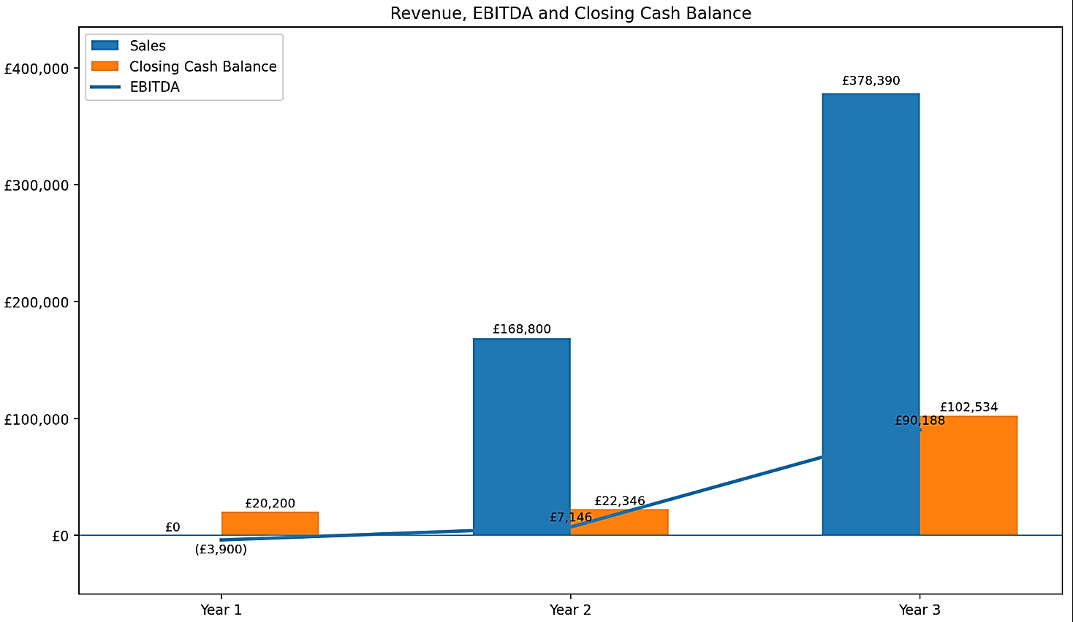
Figure 8.4-i: Revenue, EBITDA and Closing Cash Balance (Years 1–3)


Business Operations, Compliance & Institutional Readiness
This section outlines the operational, compliance, and institutional-readiness foundations that support GuidelyEdu’s market entry and long-term scale. The business is structured around the requirements of schools and Multi-Academy Trusts, combining secure digital delivery, regulatory alignment, and disciplined operational readiness within a regulated education environment.

Operational Infrastructure
GuidelyEdu operates on a cloud-first model that supports resilient platform delivery, secure data processing, and scalable customer support. At the current stage, the business remains operationally lean, with founder-level oversight and access to external legal, data protection, and financial advice as required.
Current operational foundations include structured repositories for code and documentation, controlled management of core platform assets, and protection of brand identity through a UK trademark registration in Class 42. These foundations provide a disciplined base for continued development and institutional onboarding.
Before first trust deployment, the operating environment will include business continuity and disaster recovery procedures, encrypted backups, defined recovery targets, incident response processes, and routine restoration testing. These measures support service continuity, operational resilience, and the secure handling of sensitive pupil data.

Governance, Compliance & Security Controls in Development
Governance responsibility sits at founder level, supported by external legal, data protection, and financial advice where required. Broader commercial and scaling risk is addressed separately in Section 11.
Compliance is embedded into the platform architecture and operating model. Platform design, data handling, and documentation processes are structured around UK GDPR, the Data Protection Act 2018, the SEND Code of Practice, and relevant safeguarding expectations, including Keeping Children Safe in Education. The platform supports professional judgement rather than replacing it, using explainable outputs, structured audit trails, and transparent system logic to strengthen accountability in operational, inspection, and review contexts.
Core security and data protection measures built into the platform design include encryption in transit and at rest, role-based access controls, data minimisation, retention controls, and secure deletion processes. These controls reflect the sensitivity of pupil data and the due-diligence expectations of institutional buyers.
Information security will be strengthened further through a defined cybersecurity roadmap, including progression towards Cyber Essentials certification and broader alignment with recognised control standards as the business moves towards live institutional deployment.

Intellectual Property, Institutional Readiness & Support
GuidelyEdu’s core intellectual property and platform assets are maintained within controlled repositories and protected through appropriate contractual, operational, and governance arrangements. These include the platform’s SEND ontology, rule logic, documentation structure, proprietary codebase, and associated product materials. A UK trademark registration in Class 42 has been secured.

Controls to Be Completed Before First Trust Procurement
Before first trust procurement or live institutional onboarding, a defined set of operational and compliance controls will be completed. These include business continuity and disaster recovery procedures, encrypted backup arrangements, defined recovery targets, incident response processes, and routine restoration testing.
Institutional onboarding documentation is also being prepared to reduce procurement friction and support buyer due diligence. This includes contract templates, data processing documentation, DPIA support materials, ICO registration, and a clear compliance pack suitable for school and trust review. Customer support processes will also be formalised before live rollout, including onboarding guidance, response procedures, and structured support resources.

Institutional Readiness Position
GuidelyEdu has a clear and defined institutional-readiness framework aligned to the operational and compliance expectations of a regulated education market. At its current stage, the business should be understood as progressing through that framework rather than operating as a fully mature institutional environment today.
This is appropriate to the company’s stage of development. Core governance, compliance design, and intellectual property controls are already established, while the remaining operational and procurement-readiness measures are scheduled for completion ahead of first trust-level deployment. This provides a measured and credible basis for market entry and supports disciplined growth over time.
These foundations position GuidelyEdu to operate credibly within a regulated, procurement-led education market while supporting disciplined and scalable growth.


Organisation, Staffing & Growth Plan
This section sets out the organisational structure and phased staffing model that will support GuidelyEdu’s staged growth. Headcount expansion is aligned to contracted revenue milestones, supporting capital efficiency, operational discipline, and controlled scaling. The core principle is simple: validation precedes expansion, and revenue precedes structural overhead.

Operating Philosophy
GuidelyEdu operates a lean, cloud-first model during the validation phase. Fixed overheads are kept low, and specialist expertise is accessed through retained advisors or contract arrangements until recurring revenue justifies permanent roles. Core product direction, technical leadership, and commercial development remain founder-led during early growth. This approach preserves capital, reduces burn risk, and ensures organisational scale follows demonstrable demand rather than speculative expansion.

Founder Role, Leadership Structure and Dependency
The Founder leads product vision, technical direction, commercial strategy, trust engagement, pilot deployment, and early institutional validation. Investor and stakeholder engagement are also founder-led during the validation phase. The Founder operates without salary in Year 1 to preserve capital and maintain cost discipline while pilots are established.
This structure is appropriate at the current stage, but it also creates a clear concentration of responsibility across product, commercial, and operational execution. That dependency is recognised as an early-stage business risk rather than a permanent operating model. The first two priority hires are therefore designed not only to support growth, but also to reduce founder concentration directly. The first key hire is a Product Developer, reducing reliance on the Founder for technical delivery, implementation support, and roadmap execution. The second is a Sales Lead, reducing concentration in commercial development, trust engagement, and pipeline progression. Subsequent customer success and administrative support strengthen implementation capacity and operational resilience as recurring revenue grows.
At launch, governance and domain expertise are supported through retained advisory capacity:
- SEND Advisor (retained): regulatory alignment and practitioner validation
- Data Protection Advisor (retained DPO service): GDPR oversight and governance assurance
- Legal and Financial Advisors: ongoing commercial, contractual, and compliance guidance
As the business moves into institutional scaling, a formal strategic advisory board is expected to be established. This is likely to include a trust leader, such as a CEO or CFO, to provide procurement and governance insight, and an EdTech commercial executive to support scaled market expansion. This preserves lean governance during validation while strengthening strategic oversight as the business grows.

Organisational Structure
This structure separates product delivery, revenue generation, and regulatory control while maintaining lean coordination under founder leadership during the early stage.
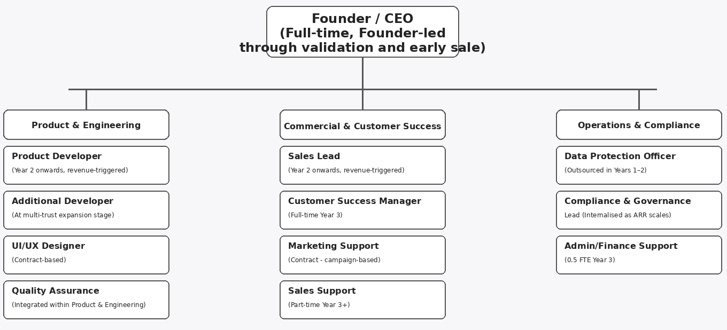
Figure 10.3-i: Organisational Structure (Revenue-aligned Model)
The business operates across three integrated functions:
- Product & Engineering — platform development, integrations, architecture, and feature roadmap
- Commercial & Customer Success — trust engagement, pilot conversion, onboarding, and retention
- Operations & Governance — compliance oversight, data protection, financial management, and quality assurance
Role development is phased to reduce founder concentration risk over time, with delivery, product, commercial, and customer success responsibilities becoming progressively more distributed as recurring revenue grows.
As the business moves beyond validation, the operating model is expected to broaden through targeted specialist support and, at the appropriate stage, advisory or non-executive input to strengthen governance, commercial discipline, sector credibility, and scale execution.

Contractor and Outsourcing Model
To preserve capital efficiency during validation and early growth, GuidelyEdu uses specialist contractors and retained advisors for functions that do not yet require full-time internal capacity. These include UI/UX design, campaign-based marketing support, retained data protection services, legal advisory support, and specialist R&D input where required. This model provides access to relevant expertise while limiting fixed overhead and avoiding premature permanent hiring.

Phased Staffing Roadmap (Three-Year, Revenue-Aligned)
Headcount expansion is aligned to contracted revenue growth and institutional validation milestones. The staffing model is designed to preserve capital efficiency during the validation phase, introduce targeted capability as commercial traction emerges, and expand operating capacity only as recurring revenue strengthens.
Table 10.5-i: Three-Year Phased Staffing Roadmap (Revenue-Aligned)
Phase | Projected Revenue | Team Build | Purpose
Year 1 – Validation Phase | £0 | Founder-led operations, retained SEND and data protection advisors, project-based specialist support | Refine the platform, deliver pilot activity, test implementation practicality, and develop early case studies
Year 2 – Controlled Scaling Phase | £168,800 | Add Product Developer and Sales Lead | Support trust pilot conversion, reduce founder dependency, and build delivery and commercial capacity in line with early contracted revenue
Year 3 – Revenue-Aligned Expansion | £378,390 | Founder, Product Developer, Sales Lead, full-time Customer Success Manager, 0.5 FTE Admin/Finance Support | Support recurring revenue growth, wider institutional deployment, stronger customer retention, and a more established operating structure
Hiring is phased against secured contracts and recurring revenue rather than speculative growth assumptions. The first two priority hires, Product Developer and Sales Lead, are intended both to support scale and to reduce founder concentration risk across technical delivery and commercial execution.
Year 1 – Year 1 is treated as a non-revenue validation phase. The principal objective is to establish product usability, implementation practicality, and early institutional relevance through pilot activity and case-study development rather than short-term revenue generation. Cost discipline is maintained, with no fixed headcount expansion during this phase.
Year 2 – Year 2 represents a structured investment phase aligned to early paid conversion and first trust-level contracts. Core hires are phased across the year and triggered by secured contracts. The Product Developer and Sales Lead are the first two capability hires because they directly reduce founder concentration risk across technical delivery and commercial execution. Customer success and administrative support remain founder-led and advisor-supported during Year 2 and are formalised in Year 3 once recurring revenue is stronger. Additional investment in sales, marketing, and product development supports institutional entry. Hiring remains milestone-aligned so that expansion follows secured recurring revenue rather than speculative pipeline growth.
Year 3 – Headcount scales proportionately to contracted recurring revenue:
- Founder (Product & Technical Leadership)
- Product Developer
- Sales Lead
- Customer Success Manager (full-time)
- Admin/Finance Support (0.5 FTE)
By Year 3, recurring revenue supports a more established operating structure, with reinvestment focused on market expansion, customer support, and product depth. Founder dependency should also be materially lower than during the validation phase, as delivery, sales, and customer support responsibilities become more distributed.

Organisational Scaling Model
Organisational expansion follows commercial triggers rather than fixed timelines. Headcount growth is aligned to contracted recurring revenue and institutional validation milestones.
Expansion is activated by:
- Trust-level contract conversion
- Stable multi-trust pipeline development
- Contracted ARR thresholds
- Sustained recurring revenue growth
The business does not scale fixed headcount ahead of demonstrable revenue. This is important not only for cost discipline, but also for risk reduction. The staged hiring model is designed to reduce founder concentration progressively as the business moves from validation into institutional growth.
Table 10.6-i: Phased Scaling Structure (Revenue-Aligned)
Phase | Team Structure | Strategic Focus | Cost Discipline
Pre-Launch | Founder + retained advisors | Product foundation and compliance setup | Minimal burn
Phase 1 – Validation | Founder-led + contract support | Pilot deployment and case-study generation | Lean
Phase 2 – Trust Entry | Product Developer, Sales Lead | Institutional validation and trust conversion | Milestone-triggered hiring
Phase 3 – Portfolio Scale | Founder, Product Developer, Sales Lead, full-time Customer Success Manager, 0.5 FTE Admin/Finance Support | Multi-trust deployment and retention | Revenue-aligned growth
This staged approach ensures alignment between people costs, contracted revenue, and operational complexity, while reducing single-person dependency over time.

Capability Priorities
As the organisation scales, recruitment will prioritise individuals with sector-relevant expertise and regulated SaaS experience. Key capability areas include cloud-native product development, secure data handling, education-sector sales, procurement-cycle literacy, customer success within institutional environments, and UK GDPR compliance. Hiring decisions are aligned to contracted ARR thresholds so that new capability is introduced proportionately to revenue growth and operational need.


Risk Management & Governance

Risk Context
GuidelyEdu operates within a regulated, procurement-led education environment in which product credibility, institutional trust, and disciplined execution are central to commercial success. Risk management is therefore embedded within the business model, product design, operational planning, and route-to-market approach from the outset. The company’s growth strategy is intentionally staged, with product validation preceding wider institutional rollout so that expansion is supported by evidence rather than assumption.
GuidelyEdu is designed with privacy, security, and institutional control embedded into its architecture from the outset. The platform is intended to operate on a data-minimisation basis, with access restricted to authorised users and appropriate administrative oversight at school and trust level. Security design is expected to include encrypted data handling, secure cloud infrastructure, and controlled access management, supporting the responsible handling of sensitive SEND-related information within a UK education context. Given the sensitivity of SEND-related evidence, platform credibility depends not only on functional performance but also on secure data handling, clear access controls, and alignment with UK data protection expectations.
At this stage, the principal risks are not limited to technical or regulatory factors. They also include adoption timing, procurement delay, founder concentration, capital discipline, institutional misunderstanding of the product’s role, and the challenge of converting early validation into recurring revenue. These risks are typical of an early-stage regulated SaaS business, but they are particularly important in a market where trust-level procurement cycles can be slow and institutional credibility is essential.

Risk Management Approach
The company’s mitigation approach is based on disciplined sequencing rather than aggressive front-loaded scale. Hiring and cost growth are aligned to contracted revenue and delivery milestones, reducing the risk of fixed-cost expansion ahead of commercial proof. Product development is structured around modular architecture, explainable outputs, audit traceability, and secure integration principles so that regulatory, technical, and operational changes can be managed without requiring full product redesign.
Commercial risk is managed through a validation-led route to market in which pilot evidence is used to test workflow benefit, documentation value, and implementation practicality before wider institutional rollout is pursued. This reduces the risk of overcommitting resources to unproven assumptions and helps ensure that trust-level commercial engagement is supported by demonstrable operational relevance.
The business also recognises that some risks cannot be removed entirely. Procurement timing, school budget pressure, policy change, and competitive response remain inherent features of the sector. The objective is therefore not to eliminate uncertainty, but to manage it through conservative planning, staged growth, and proportionate governance.

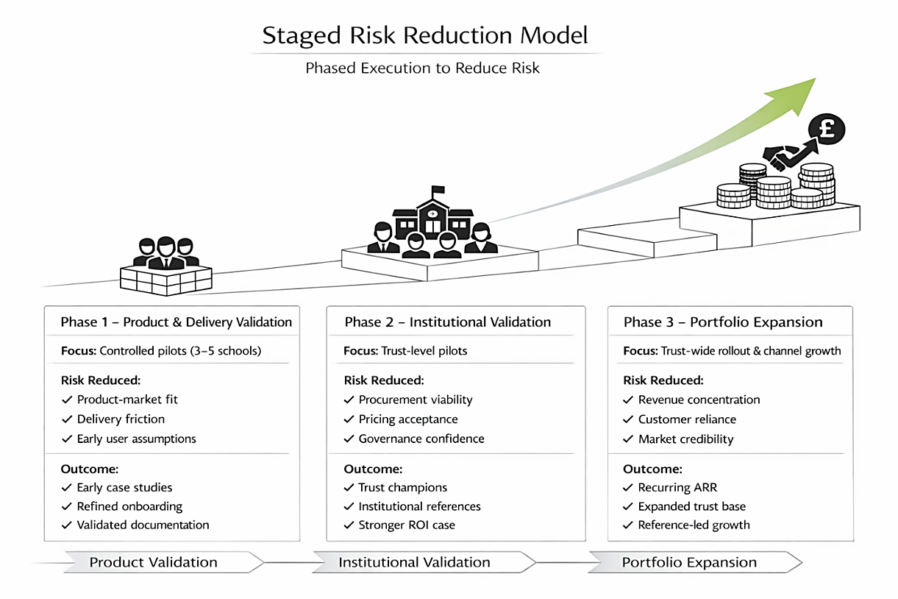
Figure 11.2-i: Staged Risk Reduction Model
Illustrative model showing how risk is reduced through phased progression from validation and pilot delivery to wider institutional and trust-level expansion.
A supporting SWOT summary is included in Appendix E3 and should be read alongside this section and the formal risk register in Section 11.3.

Risk Register
This risk profile is realistic for the company’s stage. Several risks, particularly founder dependency, procurement timing, and pilot conversion, are materially important in the near term and are reflected directly in the staged operating model.
Table 11.3-i: Risk Register
Risk | Probability | Impact | Mitigation
Slow trust adoption | Medium | High | Pilot-led evidence generation; phased trust engagement; validation before wider rollout
Long procurement cycles versus limited capital | Medium | High | Lean cost base; milestone-triggered hiring; controlled overhead growth
Founder dependency | High | High | First two core hires are Product Developer and Sales Lead; retained advisors support governance and specialist functions; responsibilities distributed progressively as revenue grows
Insufficient pilot impact | Medium | High | Pre-defined pilot success metrics; iterative product refinement; careful pilot selection; case-study-based learning before wider scale
Integration delays or onboarding friction | Medium | High | Integration-first architecture; phased rollout; structured import templates where full connectivity is delayed; selective implementation oversight
Trust concentration risk in go-to-market model | Medium | Medium | School-level pilots used to generate proof and internal advocacy; expansion pursued across multiple institutions over time rather than dependence on a single customer group
Forecast under-delivery or slower conversion than modelled | Medium | High | Conservative scaling assumptions; revenue-aligned hiring; staged commercial model; non-revenue validation phase already built into the forecast
Competitive pressure or partial replication by incumbents | Medium | Medium | Proprietary SEND ontology, rule logic, documentation framework, and depth-first specialisation in statutory interpretation
Regulatory or inspection framework change | Medium | Medium | Centralised ontology updates; modular rule architecture; ongoing monitoring of SEND and inspection developments
Data protection or cybersecurity failure | Low | High | Encryption, role-based access controls, minimisation principles, secure deletion, audit logging, and progression towards formal security assurance
Misunderstanding of the platform as replacing professional judgement | Medium | High | Clear product positioning, transparent outputs, explainable logic, audit trails, and contractual and user guidance confirming that the platform supports rather than replaces practitioner judgement
Reputational damage from weak early deployments | Medium | Medium | Controlled pilot scope; close implementation oversight; measured expansion only after operational fit is demonstrated

Governance Oversight
Governance oversight remains proportionate to the company’s stage while reflecting the requirements of a regulated education market. Founder-level accountability currently sits at the centre of operational oversight, supported by retained legal, data protection, financial, and SEND advisory input where specialist judgement is required. This provides a lean but structured governance base during the validation phase.
As the business progresses towards institutional scale, governance capacity will strengthen through more formalised advisory support and clearer distribution of operational responsibilities. This will reduce single-person dependency, improve control maturity, and support stronger institutional assurance as trust-level adoption develops.
Risk review forms part of ongoing product, operational, and commercial decision-making. Particular attention will be given to procurement timing, pilot performance, data protection readiness, and the pace at which founder-led responsibilities are transferred into newly hired capability.


Founder Profile & Strategic Vision
GuidelyEdu is founded and led by Bukola Kale, whose background combines direct sector experience in Special Educational Needs and Disabilities (SEND) with the ability to translate complex statutory processes into structured digital systems.
The business is rooted in first-hand exposure to weaknesses in SEND documentation and compliance practice. Through work across school-based SEND provision, safeguarding environments, multi-agency coordination, and Local Authority EHCP processes, Bukola developed a detailed understanding of how fragmented evidence, inconsistent documentation, and administrative burden can weaken decision-making, review quality, and statutory defensibility. This insight is grounded in direct experience of the operational pressures faced by practitioners and institutions.
What differentiates the founder is not only recognition of the problem, but the ability to design a credible solution. Bukola brings practical knowledge of the SEND Code of Practice, Assess–Plan–Do–Review processes, safeguarding requirements, and data governance, as well as the capability to convert these frameworks into structured, explainable system logic. This has shaped GuidelyEdu’s core product approach: a deterministic compliance architecture designed to connect source evidence, statutory interpretation, and traceable documentation outputs.
Founder suitability is further evidenced by tangible execution progress within the company. GuidelyEdu has advanced to a structured prototype stage, with core product architecture defined, an initial SEND statutory ontology developed, and early rule-based reasoning components designed to support controlled validation. GuidelyEdu progress also includes early market engagement, the development of a phased commercial model, and protection of brand identity through UK trademark registration in Class 42. These steps demonstrate not only problem insight, but disciplined conversion of that insight into the business development.
Bukola Kale’s technical capability is strengthened by a Master’s degree in Digital Health and Artificial Intelligence from Bournemouth University, supporting the analytical, technological, and systems-thinking base underpinning GuidelyEdu’s development. Her academic progression also includes doctoral research at the University of the West of Scotland, focused on the co-design of GuidelyEdu as part of the company’s wider research and development pathway.
This combination of domain expertise, technical understanding, execution progress, and research-led development provides a credible foundation for delivery. The business has been shaped with a disciplined commercial approach centred on validation, institutional adoption, and phased scaling through school- and trust-level implementation. This reflects an understanding not only of the product challenge, but also of how adoption occurs within regulated education settings.
Bukola Kale’s profile supports the case that GuidelyEdu is led by a founder with the sector credibility, problem understanding, execution discipline, and strategic focus required to build a viable and scalable business. The long-term vision is to establish GuidelyEdu as a trusted compliance and documentation infrastructure layer for SEND governance across Multi-Academy Trusts.


Strategic Conclusion
GuidelyEdu addresses a clear and growing structural need within the UK Special Educational Needs and Disabilities (SEND) system. As evidential expectations, EHCP volumes, and trust-level accountability continue to increase, schools and Multi-Academy Trusts require more consistent and defensible approaches to SEND documentation and oversight. Existing systems support record-keeping, but they do not adequately convert dispersed evidence into structured, explainable, and governance-ready documentation.
GuidelyEdu addresses this gap by embedding rule-based statutory interpretation within school workflows and generating clearer, audit-ready outputs that support both operational practice and institutional oversight. Its model is designed to align with existing school and trust structures, enabling adoption alongside core systems rather than requiring their replacement.
The business is grounded in a credible understanding of sector need, a clearly defined product concept, and a phased commercial pathway based on validation, institutional adoption, and trust-level expansion over time. These elements support the case for GuidelyEdu as a credible, capital-disciplined business with a realistic pathway to commercial viability and institutional scale in an area of sustained and growing demand.


Appendix
This appendix contains supporting material referenced in the main business plan, including product workflow examples, validation evidence, go-to-market visuals, financial projections, product design documentation, and intellectual property confirmation. Where appropriate, selected materials are provided as separate supporting files for readability and document control.

Appendix A: Product Design, Workflow and Governance Structure
Product development activity is focused on the internal refinement of the platform’s statutory knowledge structure, rule logic, workflow architecture, and documentation automation capabilities, which form the core of the company’s applied development and R&D effort.
This development work is intended to improve rule coverage, workflow usability, output quality, and institutional scalability rather than depend on generic software implementation alone.

A1. Platform Architecture and MIS Integration Overview
Illustrative architecture showing how school MIS data is integrated into GuidelyEdu’s rule-based statutory engine, workflow logic, and governance outputs. See Appendix A1 supporting document for integration flow.
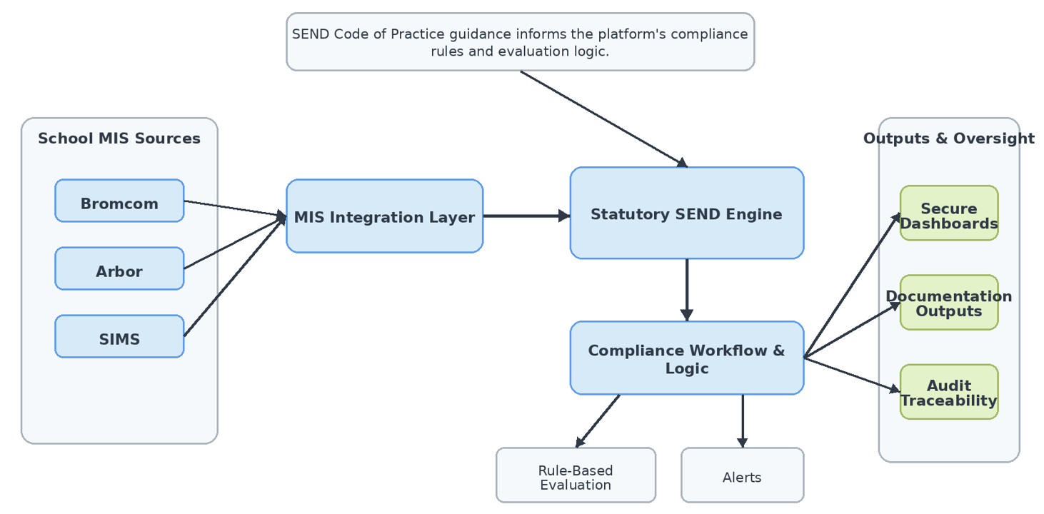
Figure 14.1-i: Appendix A1 - Platform Architecture and MIS Integration Overview

A2. GuidelyEdu Platform Overview and Core Functional Layers
Illustrative overview of GuidelyEdu’s core functional layers, documentation workflow, intended beneficiaries, and current product development position. Supporting document (Appendix A2) shows workflow design.
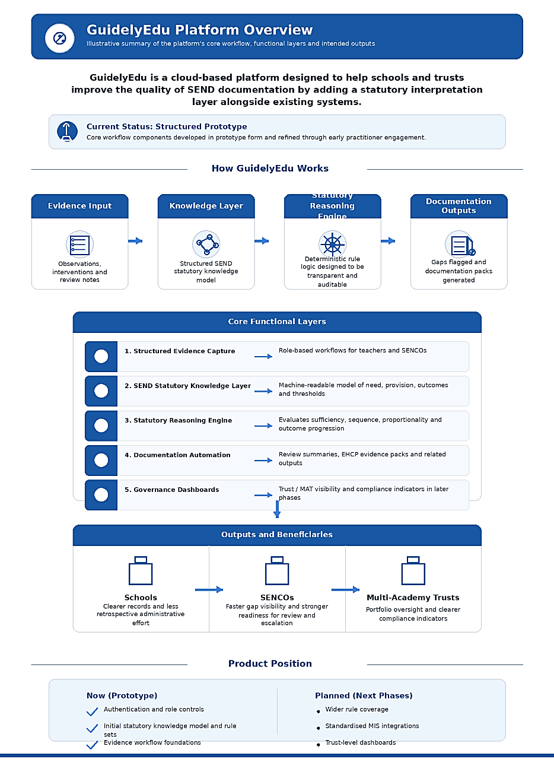
Figure 14.1-ii: Appendix A2 - Platform Overview and Core Functional Layers

A3. Platform Interface Wireframes (Separate Supporting Document)
Supporting wireframes illustrating the platform’s interface architecture, workflow structure, compliance decision-support layer, and governance monitoring design.

A4. Product Workflow (Separate Supporting Document)
Supporting workflow illustrating how evidence organisation, threshold evaluation, and human-led professional decision-making, governance flow, documentation outputs, and audit traceability structure operate within the platform.

Appendix B: Validation Evidence & Commercial Support

B1. Practitioner Engagement Overview
Early practitioner engagement to date has included 3 substantive conversations and product demonstrations conducted between August 2025 and February 2026. These discussions involved stakeholders across school SEND leadership, former local authority / headteacher leadership, and SEND-related digital practice. Engagement formats included exploratory discussions, product demonstrations, and follow-up conversations. The purpose was not to secure formal purchase commitment at this stage, but to test whether the operational problem is recognised in practice, whether existing tools are viewed as sufficient, and whether the proposed solution direction is commercially relevant.
This engagement remains exploratory and does not yet constitute formal pilot activity, contracted demand, or commercial conversion. Nevertheless, it provides useful early-stage evidence that the underlying problem is real, widely recognised, and aligned with a meaningful solution need within the sector.
Table 14.2-i: Appendix B1 - Summary of practitioner and Sector Engagement
Context | Role | Engagement stage | Validation outcome | Commercial relevance
Mainstream Secondary School (Essex) | SENDCo | Product demonstration completed; follow-up scheduled | Confirmed high annual review workload and strong interest in structured compliance automation | Supports school-level user demand and potential pilot suitability
Local Authority (Worcestershire) | Former Headteacher / SEND Lead | Exploratory discussion | Confirmed systemic inconsistency in documentation and significant administrative burden | Supports broader institutional relevance beyond a single school setting
Local Authority / Regional Specialist Context (Greater Manchester) | SEND & AI Integration Specialist | Product demonstration completed | Validated the need for a structured and standardised evidence framework | Supports technical and workflow relevance of the proposition

B2. Supporting Extracts
Selected supporting communications and practitioner responses are included below as supplementary evidence of early validation.

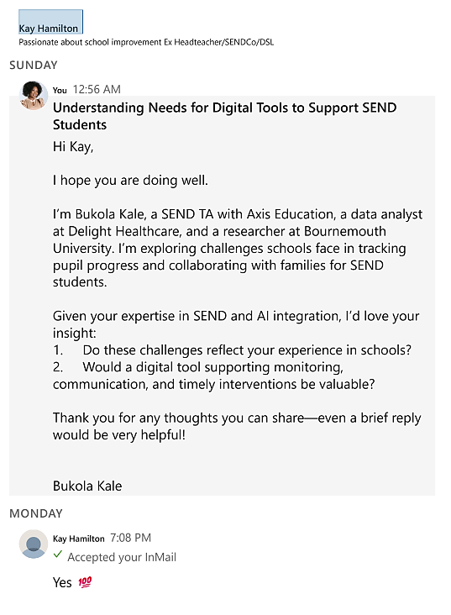
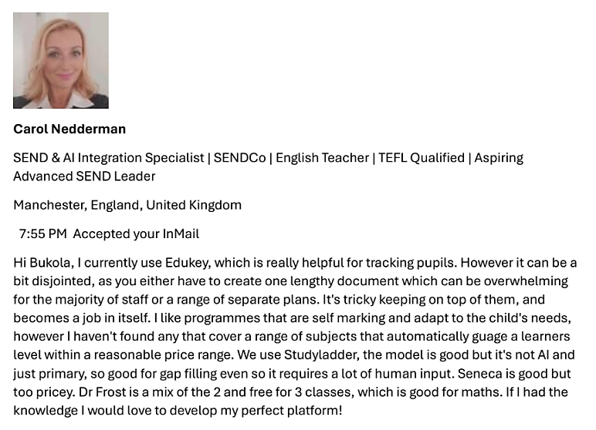
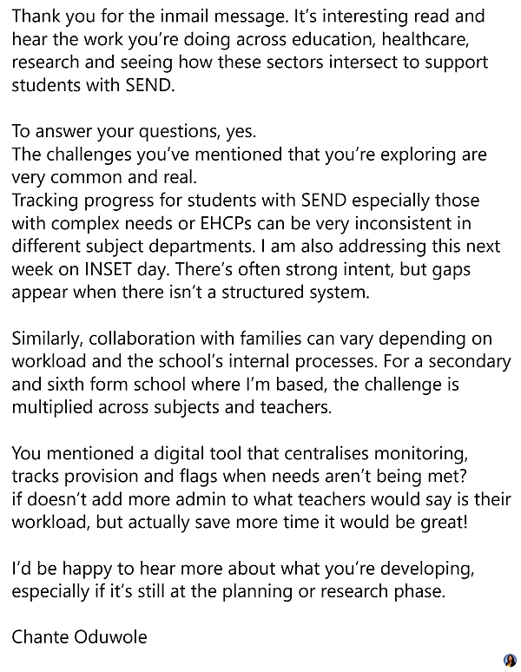
These extracts are to illustrate the practical relevance of the problem and the response to the proposed solution direction. Evidence of practitioner discussions, demonstrations, and early market engagement informing product design and commercial validation.

Figure 14.2-i: Appendix B2 – Supporting Evidence of Practitioners Engagement

B3. Key Findings from Early Engagement
Early engagement generated four recurring findings.
- The problem is recognised in practice: Across the engagements undertaken, respondents consistently described SEND documentation as difficult to manage where information is spread across staff, files, systems, and review cycles. This supports the proposition that the problem addressed by GuidelyEdu is operationally real rather than theoretical.

- The burden is operational, not only administrative: Feedback suggested that the challenge is not simply paperwork volume, but the difficulty of maintaining a current, coherent view of pupil need, provision, progress, and review readiness across fragmented sources of evidence.

- Existing systems only partially address the workflow: Respondents indicated that schools may already use digital systems or trackers, but these were described as incomplete, manual, or insufficiently joined up for whole-school or trust-level oversight. This supports the view that the market gap is not for another isolated tracker, but for a more structured and integrated documentation layer.

- Time saving is a precondition for adoption: A consistent theme was that any new platform would need to reduce workload, simplify evidence collation, and fit naturally into existing practice. This is commercially important because it directly shapes product design, onboarding expectations, and procurement positioning.

B4. Strategic Implications for GuidelyEdu
This early validation strengthens the commercial rationale for GuidelyEdu in several important respects. First, it supports the proposition that SEND evidence management remains operationally difficult within existing school processes. Second, it suggests that there is practitioner interest in a more structured system that centralises information, improves visibility, and supports earlier identification of evidential gaps. Third, it reinforces the view that the market opportunity lies not simply in providing another tracking tool, but in addressing the wider problem of fragmented documentation and inconsistent oversight.
The feedback also supports the business’s proposed pilot-led route to market. Institutions are likely to require practical evidence that the platform can improve workflow efficiency, strengthen documentation consistency, and fit naturally within school practice before wider procurement decisions are made.

B5. Evidence Position
The material presented in this appendix should be understood as early validation rather than formal commercial proof. It does not yet represent contracted pilot traction, purchase commitment, or recurring revenue. However, it materially improves confidence that the problem being addressed by GuidelyEdu is genuine, that the proposed solution direction is credible, and that further pilot-stage development is commercially justified.

B6. Near-Term Validation Priorities
The next stage of validation should convert qualitative feedback into structured commercial proof. The immediate priorities are:
- Secure at least one formal pilot setting
- Define pilot success measures linked to workload reduction, documentation completeness, and practitioner usability
- Generate a case-based evidence summary from pilot use
- Use that evidence to support trust-level and school-level commercial discussions
This staged approach is consistent with the wider business plan and provides a more credible bridge between early market validation and future institutional adoption.

Appendix C: Go-to-Market Visuals

C1. Phased Go-to-Market Roadmap
Structured progression from school validation to trust-level adoption and portfolio expansion.
Illustrative roadmap showing the progression from validation to institutional traction and portfolio expansion, aligned to the three-year commercial model.
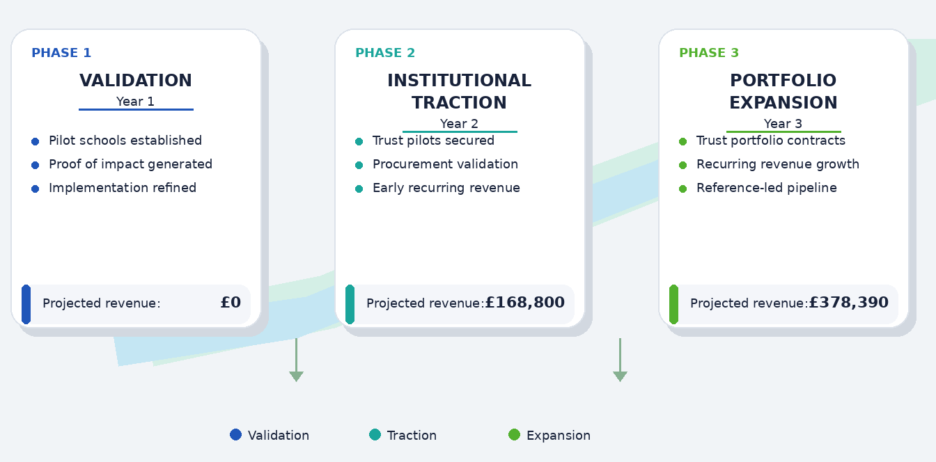
Figure 14.3-i: Appendix C1 - Go-to-Market Roadmap

C2. Market Engagement & Expansion Channels
Illustrative view of the principal channels supporting early engagement, pilot generation, institutional conversion, and trust-level expansion.

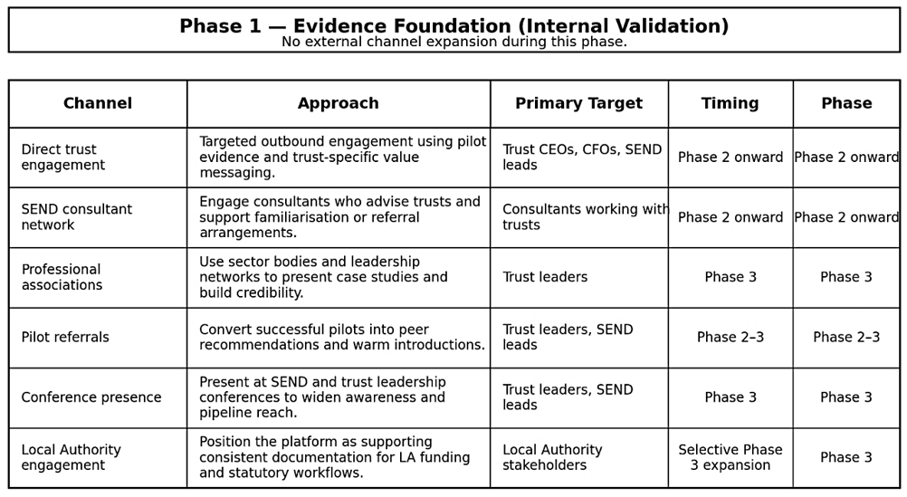
Figure 14.3-ii: Appendix C2 - Market Engagement & Expansion Channels

Appendix D: Financial Projections

D1. Revenue Assumptions (Pricing & Scaling)
The three-year financial model is based on explicit pricing, school coverage, and phased commercial conversion assumptions. Year 1 is treated as a non-revenue validation phase. Commercial revenue begins in Year 2 through a combination of individual school subscriptions and trust-level rollout, with broader institutional scaling in Year 3.

  - Illustrative Pricing Structure
These tiers illustrate the current base-case pricing structure used for financial modelling. Actual pricing for live contracts may vary by scale, deployment scope, and support requirements.
Table 14.4-i: Appendix D1 - Pricing Tier
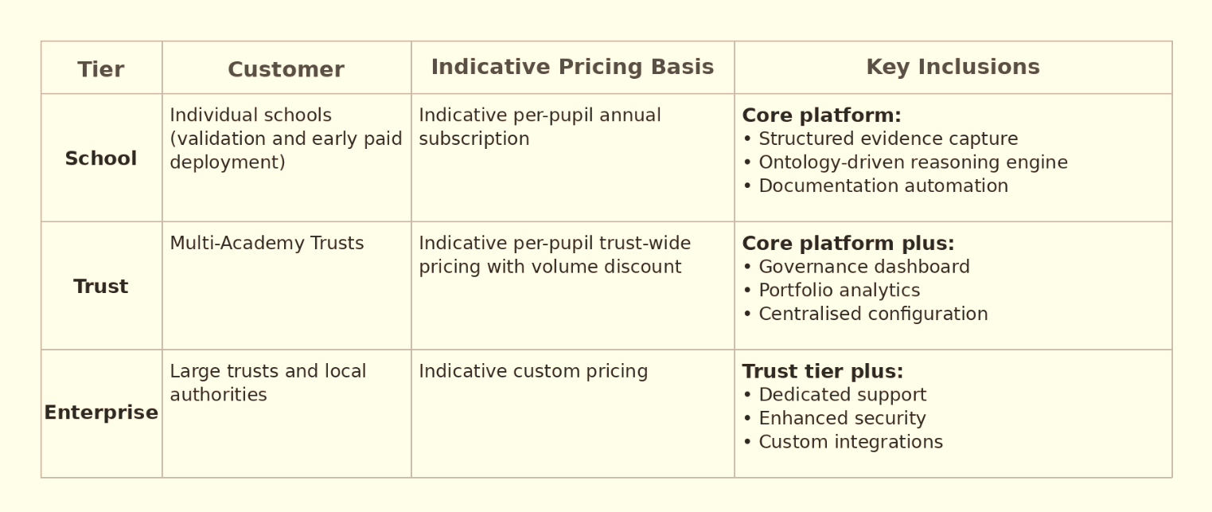
  - Core Pricing Assumptions
Table 14.4-ii: Appendix D1 - Core Pricing Assumptions
Variable | Assumption | Notes
Per-pupil annual price | £8 | Base-case subscription assumption
Average pupils per academy | 500 | Conservative mainstream average
Trust-level discount | 15% | Applied to portfolio rollout
Individual school pricing | £8 per pupil | No trust discount applied
Billing structure | Annual subscription | Supports recurring revenue visibility

  - Illustrative Contract Values
Illustrative contract values are shown for explanatory purposes only. Forecast figures in the financial model reflect the detailed spreadsheet assumptions and calculations.
Table 14.4-iii: Appendix D1 - Contract Values
Contract Type | Illustration | Annual Value
Individual school subscription | 500 pupils × £8 | £4,000
Trust portfolio subscription | 8 academies × 500 pupils × £8 × 85% | £27,200

Table 14.4-iv: Appendix D1 - Institutional Scaling Summary
Metric | Year 1 | Year 2 | Year 3
Pilot schools / validation deployments | 5 | – | –
Paid individual school subscriptions | – | 5 | 10
Schools covered through trust-level rollout | – | 32 | 96
Total schools covered | 5 | 37 | 106
Projected Revenue (£) | 0 | 168,800 | 378,390
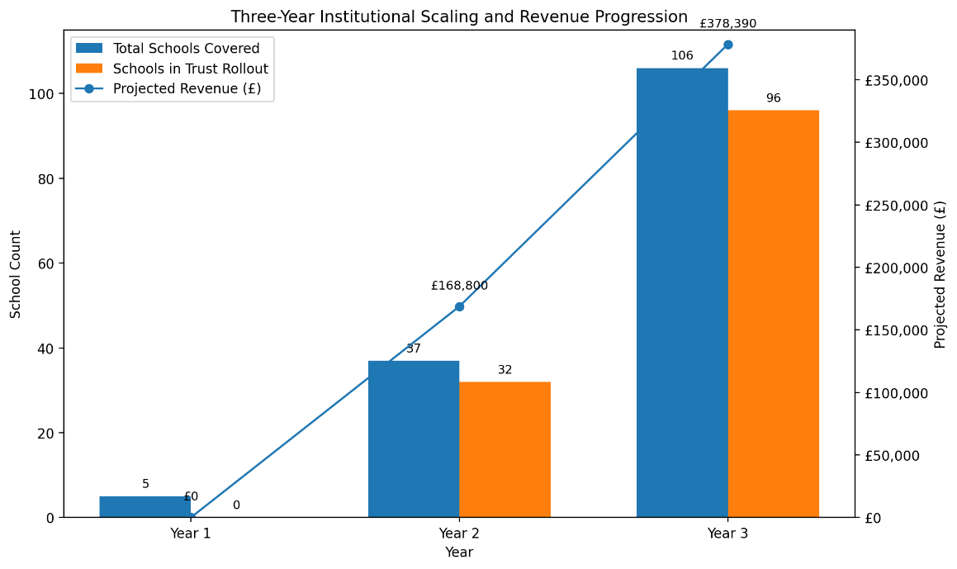

Year 1 is modelled as a validation period rather than a fully commercial year. This reflects the likely procurement and relationship-building cycle in the education sector, where trust-level adoption is more likely to follow pilot engagement and implementation confidence than immediate paid conversion.

D2. Revenue Progression (3-Year)
Projected revenue is driven primarily by recurring subscription income derived from paid individual school subscriptions and trust-level rollout across academy portfolios, with early commercial conversion supported by initial implementation and onboarding activity where applicable.
Table 14.4-v: Appendix D2 - Revenue Progression (3-Year)
The revenue client counts shown below are modelling units and should be read alongside the institutional scaling and MAT conversion explanation in Section 8.2.
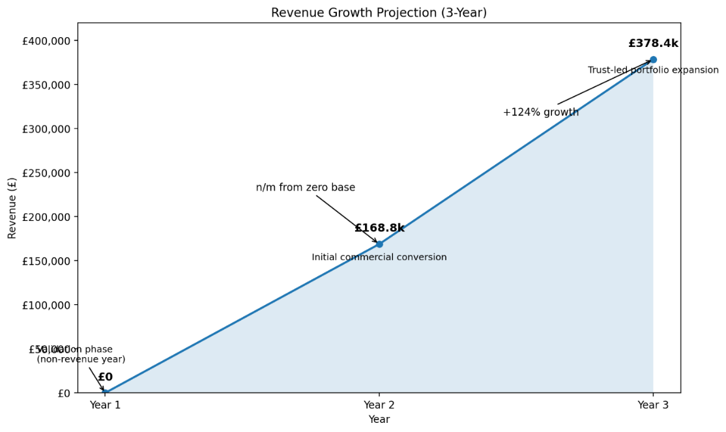
Figure 14.4-i: Appendix D2 - Revenue Growth Projection (3-year)
This profile shows that recurring subscription revenue becomes the principal driver of growth from Year 2 onward, while any initial implementation activity plays a supporting role during early commercial conversion. By Year 3, scale is driven predominantly by recurring subscription revenue.

D3. R&D and Capitalised Product Development
Capitalised R&D supports ongoing platform refinement and capability development across the forecast period.
Table 14.4-vi: Appendix D3 - R&D and Capitalised Product Development

D4. Cash Flow Forecast Summary (3-Year)
The cash flow forecast indicates that the business remains liquid throughout the forecast period, supported initially by founder funding and later by growing commercial revenues.

Table 14.4-vii: Appendix D4 – Cash Flow Forecast Summary (3-Year)
The modest reduction in cash during Year 2 reflects planned scaling investment as the business moves from validation into early institutional conversion. By Year 3, stronger recurring revenue materially improves cash generation.

D5. Profit & Loss Summary (3-Year)
The projected profit and loss statement reflects a planned validation year followed by a controlled move into institutional commercialisation. The model is intentionally conservative in Year 1, assuming no subscription revenue while still recognising modest direct pilot delivery cost. From Year 2 onward, revenue growth is driven primarily by recurring subscription income, which improves profitability as institutional rollout expands.
Table 14.4-viii: Appendix D5 - Profit & Loss Summary (3-Year)

D6. Balance Sheet Summary (3-Year)
The balance sheet reflects an early-stage business funded primarily through founder loan capital, with balance sheet strength improving as revenues scale.
Table 14.4-ix: Appendix D6 - Balance Sheet Summary (3-Year)
Negative shareholders’ funds in Year 1 reflect the treatment of founder funding as a director’s loan during the pre-revenue validation phase, rather than any immediate liquidity weakness. The business remains cash positive throughout the period and moves into positive net asset position from Year 2.

D7. Financial Model Methodology
The three-year model is built from explicit revenue, direct cost, staffing, marketing, liquidity, and capitalised development assumptions. No external equity funding is assumed within the forecast period. Founder remuneration is deferred during the forecast horizon to preserve working capital and maintain capital discipline during the early stages of growth.

Appendix E: Strategic and Stakeholder Analysis

E1. Stakeholder Analysis
Supporting analysis of decision-makers, operational users, and external influencers relevant to adoption and procurement.
Table 14.5-i: Appendix E1 - Decision-Makers (Trust Level)
Stakeholder | Primary Concern | Required Proof
Trust CEO | Portfolio compliance, reputational risk | Governance visibility and risk reduction
CFO | ROI, cost predictability | Scalable pricing and defensible savings
Trust SEND Lead | Cross-school consistency, early intervention | Standardisation and early-warning capability
Trust executives hold purchasing authority and evaluate at portfolio level.

Table 14.5-ii: Appendix E1 - Operational Users (School Level)
Stakeholder | Primary Concern | Required Outcome
Headteacher | Inspection performance, staff capacity | Inspection readiness and workload stability
SENCO | Evidence confidence, workload reduction | Structured documentation and time savings
Class Teacher | Simplicity, minimal time burden | Low-friction integration into workflow
School stakeholders experience the problem most acutely but rarely control budget allocation.

E2. Adoption Barriers and Mitigation Strategy
Summary of key institutional adoption barriers and corresponding mitigation measures within the go-to-market model.
Table 14.5-iii: Appendix E2 - Adoption Barriers and Mitigation Measures
Barrier | Institutional Concern | Mitigation Strategy
Budget pressure | Sustained funding constraints | Tiered trust-level pricing; volume efficiencies; value framed in time recovery and compliance risk reduction
Procurement complexity | Structured approval processes | Alignment with standard SaaS procurement; no upfront fees; predictable annual subscription
Integration risk | Disruption to existing systems | Integration-first architecture; no MIS replacement; controlled synchronisation
Workload resistance | Fear of additional administrative burden | No parallel logging: structured capture reduces collation; role-based interfaces minimise training
Proof requirement | Evidence required prior to scale commitment | Phased validation model generating measurable case studies
Access to decision-makers | Relationship-led trust governance culture | Pilot referrals, consultant networks, professional associations
The strategy emphasises incremental validation, controlled rollout, and alignment with institutional governance norms

E3. SWOT Analysis
Supporting SWOT analysis summarising internal strengths and limitations alongside external opportunities and risks within the SEND governance market.
Table 14.5-iv: Appendix E3 - SWOT Analysis
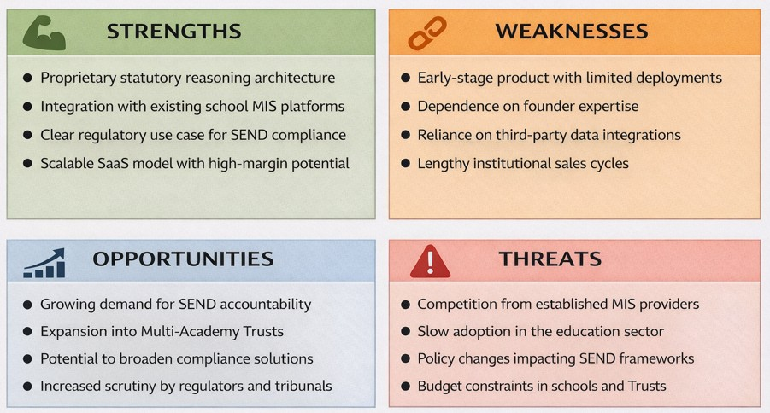
The weaknesses and threats identified in this SWOT analysis should be understood as active management priorities rather than as static constraints on the business. In particular, the business recognises that founder dependency, early-stage validation status, procurement timing, and the possibility of slower-than-expected institutional adoption are all material issues at the current stage of development. These are being addressed through a deliberately staged operating model in which hiring is triggered by revenue milestones, fixed costs are controlled, and pilot-led validation is used to generate practical proof of workflow value before wider trust-level rollout is pursued.
The business is also structured to manage external threats through disciplined product and commercial development rather than through speculative expansion. Competitive response from incumbent systems is mitigated by continued refinement of the platform’s ontology, rule logic, explainability, and documentation framework, while regulatory or compliance-related risks are addressed through ongoing monitoring of the SEND and inspection environment, modular product design, and controlled updates to the platform’s knowledge and rule architecture. Institutional-readiness risks are being managed through formal preparation of governance, data protection, onboarding, and procurement-support materials ahead of first live trust deployment.
The purpose of this SWOT analysis is therefore not only to identify the business’s current strategic position, but also to show that the principal weaknesses and threats have already been considered within the wider business model, operating plan, and risk-management approach. It should be read alongside the commercial risk and mitigation discussion in Section 7 and the formal risk register in Section 11.

E4. Comparative Technology and Platform Landscape
This table provides a high-level comparison of the principal system categories relevant to SEND documentation and governance. It is intended to support the competitive analysis in Section 6 by showing where existing platforms are strongest and how GuidelyEdu differs in addressing the structural gap around statutory interpretation, documentation readiness, and governance support.
Table 14.5-v: Appendix E4 – Comparative Technology and Platform Landscape
System category | Illustrative examples | Primary role | Main limitation | How GuidelyEdu differs
Manual / local processes | Spreadsheets, Word templates, email trails, shared folders, internal trackers | Local organisation of notes, reviews, and case records | Interpretation remains manual; weak consistency, traceability, and review-readiness | Applies structured statutory logic to evidence and supports clearer, more consistent documentation outputs
Core MIS platforms | SIMS, Arbor, Bromcom, ScholarPack, RM Integris | Whole-school administration, pupil data, attendance, behaviour, reporting | Strong at administration, but not designed for SEND-specific statutory interpretation or evidential sufficiency testing | Sits alongside MIS platforms and adds reasoning, interpretation, and documentation logic
Specialist SEND administration tools | Provision Map, EduKey, iASEND and similar tools | SEND workflow organisation, intervention logging, provision mapping, review preparation | Improve record management, but usually leave statutory interpretation to practitioners | Embeds deterministic statutory reasoning within the workflow and supports governance-ready outputs
Behaviour / safeguarding platforms | Class Charts, Sleuth and related systems | Incident tracking, behaviour monitoring, pastoral and safeguarding visibility | Useful contextual data, but not structured for SEND statutory review, EHCP logic, or documentation thresholds | Focuses specifically on SEND evidence, documentation quality, and statutory interpretation
GuidelyEdu | Proprietary SEND compliance infrastructure | Compliance-oriented interpretation and documentation layer for SEND workflows | Institutional capability is still maturing through staged validation and deployment | Designed to interpret SEND evidence against defined statutory conditions and improve documentation readiness and defensibility
Interpretive note. This comparison should be read alongside Section 6. The key market gap is not the absence of storage or workflow tools, but the absence of embedded statutory interpretation within SEND documentation workflows. GuidelyEdu’s differentiation therefore rests on its ontology, reasoning framework, documentation logic, and longer-term governance value, rather than on generic software functionality alone.

Appendix F: Intellectual Property Protection (Separate Supporting Document)
Supporting documentation relating to trademark registration and associated intellectual property protection.

Appendix G: Data and Policy Sources
G1. Market Research Evidence Summary (Secondary Data)
This table summarises selected secondary market and policy evidence supporting the need for more structured SEND documentation, review readiness, and institutional oversight within the UK education system. It should be read alongside Sections 2 and 5.
The business plan draws on official UK education statistics, statutory guidance, and policy publications to support market need, regulatory context, and institutional scaling assumptions.
Table 14.7-i: Appendix G1 – Market Research Evidence Summary (Secondary Data)
Metric / data point | Latest figure | Relevance to GuidelyEdu | Source
Pupils with SEN in England | Over 1.7 million in 2024/25, up 93,700 or 5.6% year on year | Confirms the scale of SEND-related documentation, review, and evidential pressures across the school system | Department for Education, Special educational needs in England, 2024/25 (Explore Education Statistics)
Children and young people with active EHC plans | 638,745 active plans in January 2025, up 10.8% from January 2024 | Shows the scale of statutory planning and review activity relevant to structured, defensible documentation | Department for Education, Education, health and care plans, 2025 (GOV.UK)
Pupils on SEN support | 14.2% of pupils in 2024/25 | Demonstrates that the need for better SEND evidence and documentation extends beyond pupils with EHC plans | Department for Education, Special educational needs in England, 2024/25 (Explore Education Statistics)
Total schools in England | 24,479 open schools at January 2025 | Indicates the scale of the potential implementation base across English schools | Department for Education, Schools, pupils and their characteristics, 2024/25 (Explore Education Statistics)
High needs funding budget | £12 billion for 2025 to 2026, with £11.3 billion initially distributed through the national funding formula | Supports the case that SEND remains a major funded area of school and trust activity, strengthening the relevance of governance-aligned infrastructure | Department for Education, High needs funding: 2025 to 2026 operational guide (GOV.UK)

G2. References
Department for Education
Special Educational Needs in England, Academic Year 2024/25
Explore Education Statistics
Department for Education
Education, Health and Care Plans: England 2025
GOV.UK
Department for Education and Department of Health and Social Care
SEND Code of Practice: 0 to 25 Years
GOV.UK
HM Government
SEND and Alternative Provision Improvement Plan
GOV.UK
HM Government
SEND and Alternative Provision Roadmap
GOV.UK
Department for Education
Multi-Academy Trusts by MAT Characteristics
Explore Education Statistics
Department for Education
National Multi-Academy Trust Data by Trust Characteristics
Explore Education Statistics
Department for Education
Schools, Pupils and Their Characteristics, Academic Year 2024/25
Explore Education Statistics

